**1961**

There is vomiting, crying, teething, potty training, doctor appointments, splints, special shoes, fevers, and many sleepless nights. The jets from O’Hare are so loud they interrupt conversations, TV, and most importantly, sleep. Church is missed! There are three children, and the oldest is barely 3. It must have been all consuming, and endlessly tiring. But the image of 1961 that I like best is the one of Dad lying on the bed, or sitting on the couch, pad of paper in hand, with one or more of his children climbing on top of him, or sitting in his lap, or trying to grab his pen, still managing to write to his mother, week after week after week after week.

**1-1-61 – Sun 5:00 PM -** Dear Mother, I’ll write this now and let Ruth read it this evening when I go visit her at the hospital from 7:00 to 8:00. The other visiting time is 2:00 to 3:00. They only allow one visitor at each time and it has to be either the husband or relatives.

I’m assuming, of course, that Uncle Clyde told you (I’m trying to watch TV too) that I called about the arrival of Carroll Alan Smith. I wasn’t sure that Uncle Clyde got the name straight. We’ll call him Alan. At Ruth’s appointment last Tues the Dr. agreed that we live quite a ways out and suggested that Ruth come in Thurs or Fri morning and he would “help” things along. We decided on Fri since we’d have a little more time to get things ready. We arrived about 10:00 AM Fri morning. Ruth was in labor by noon and Alan arrived about 6:05. I got to stay with Ruth until near the end. She, of course, was quite tired afterwards but didn’t sleep as well that night as she did last night.

One of the Lester’s boys (Steve) had the mumps so they couldn’t take the girls for the first day like they had planned. We had our regular babysitter come for the entire day and she apparently got along OK. I had to go pick her up in the morning and take her back in the evening after I got back about 8:00. I got the girls in bed and made the calls. I called Mrs. L and she was not surprised and had thought she’d probably be in Chicago before this. Besides Hutchinson I called the Lesters, Dallas Musgrave, our neighbors to the North and Dale Johnson (Ruth’s friends, formerly of Oberlin).

Its now Mon morning and we’re watching the Rose Bowl Parade. Sat morning I took care of the girls and at 1:00 went and got the babysitter so I could visit Ruth. The girls went down for their naps just as I left and slept until just before I got back about 3:45. We had an early supper and spent the rest of the evening doing some reading and studying.

Sun morning I got the girls ready and we drove down to meet Mrs. L. She had taken a train from McCook, Neb at 8:30 Sat night and got here at 9:05 the next morning. It was my first drive downtown. Previously I had never driven beyond the hospital area. It is actually only a few minutes beyond the hospital and medical center area to get downtown. Mrs. L was already there as we were a few minutes late. We got back here a little after 10:00 AM. Mrs. L was quite tired as she hadn’t slept much on the train so I didn’t try to take Lesle to church. Lisa had a cold and couldn’t have gone. I visited Ruth in the afternoon. When I got home Lisa had just vomited and has been sick since.

Sun night I went back down to visit Ruth and then read awhile before going to bed. Lisa had gone to bed early and awakened in the night. Naturally Lesle got up also and wanted to be rocked too. I was up several times with both of them and Mrs. L was up some also. I finally had to bring Lisa to bed with me to get her to quiet down. Lisa hasn’t vomited this morning but is now asleep and didn’t want anything to eat for breakfast.

Mrs. L has caught up on all the washing. The men are to come today or tomorrow to pick up the washer for repairs which will run $60-70. I thought we’d have it repaired before the baby got here but they couldn’t fix it until now. We’ll have to use the laundermate until the washer gets back.

I painted some on the bookcase boards this morning and we all watched the rose bowl parade. I’m watching a bowl game now and will go down and visit Ruth in a little bit. It snowed some last night and this morning.

Its now 8:30. Ruth was feeling better this afternoon and Lisa is much better this evening – she ate some supper. Ruth has made new green and white checked lining for the basket and we also have a new cradle that the Laidigs sent.

I’ll go to work tomorrow and will go visit Ruth in the afternoon. Dallas Musgrave went to see her tonight.

We had to take our Christmas tree down several days ago as it was getting so dry. Our package was sent to Newton by express but should be there by now. Among other things Lesle got a new blackboard on a stand and various smaller things.

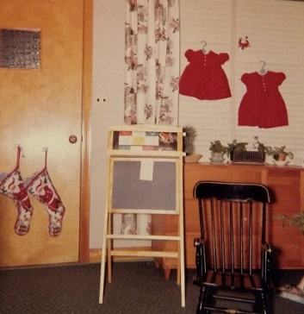

Your old box held OK and we’ve used the blanket. I study about as much at night as I did before but there is not as much pressure, etc. I’ll return some of the things in another letter. Do the Kuhns live in Wichita? They were scheduled for a show at the county fair in Oberlin the day we left last August. Tell Aunt Clara, Uncle Clyde, M.J. Bill Jimmy and all hello.

**1-20-61 – Wed 10:00 AM –** I’ll start this at work as I have a little time. As usual, I meant to get this written before this. We were glad to have your letter and Alan says “Thank You” for the bond. We have had good weather for everything and Alan and Ruth came home last Fri (in the hospital one week). Yesterday, (and todays prediction also) the temperature reached the 40’s. This is quite a bit above the normal for this time of the year here. I imagine the girls will get outside some today. The snow is practically all gone but we’ll undoubtedly have lots more. At least we’re thankful that Alan got here OK without any difficulty.

The babysitter we’ve used is only a freshman in high school but seems conscientious and called her mother when she wasn’t sure about something. Ruth is feeding Alan all she can but has to supplement with the bottle some. He eats every 3-4 hrs (usually 3 at night ha!) so he usually awakens us 3 times during the night (we go to bed early). His nose is bigger than the girls were so he’ll probably have one about like mine. Ruth says his mouth is like mine, especially like mine when I’m writing (I guess M.J. does that some, too). Otherwise in the face, he looks like the girls did, I guess (blue eyes, of course). He hates to have his diaper changed and is usually more content on his stomach. (He sleeps on his stomach.) The bottle milk doesn’t agree with him as much as his mothers so he cried quite a bit one time when he had only a bottle. He’s only spit up a little bit so I guess we really can call him a “good baby” so far. He sleeps in the basket at night (it fits in our room better) and most of the day in the cradle. His legs were quite skinny when he was born but are already beginning to fill out some. Lisa was shorter and weighed a lb more so was plumper when born.

Last week I visited Ruth from 2-3:00 PM on Tues Wed and Thurs. I took them home Fri afternoon at that time. We think Blue Cross and Blue Shield will cover all expenses although there might be some extra for the room. Presbyterian St. Lukes is one of the nicest, and most expensive, hospitals. Ruth’s bed could be raised or lowered by pressing a button which operated a motor. She could also talk to a nurse through an inter-com system. She was on the 7th floor of the new (4 yrs old) section (13 floors high). The delivery and labor rooms are in the older section which is not as high. St. Lukes Hospital used to be downtown before it joined with Presbyterian.

Last Tues evening the girls and I took Mrs. L down so she could visit Ruth. Her throat (had been getting sore) was better so she agreed she’d like to see the room, etc. The girls and I waited in the lobby at the place where we waited for Ruth when she had her checkups. I visited Ruth Wed and Thurs evenings so she had a visitor at all the visiting periods except one on the first Sat evening (New Yrs eve).

The girls get along real well with grammy but when daddy is there Lesle thinks I should do certain things for her which someone else could do just as well. I may have mentioned how Lisa toes in. We have an appointment with a Dr. Fri to check on it. She’ll probably at least have to wear pads in her shoes and may have to wear a brace soon. Lesle toed in some but the pads in her shoes have completely corrected it. I don’t think Lisa is quite as bad as she was. Last Fri the girls were quite excited when Mommy and the new baby came home and seem to take it all very well. We give them all the attention we can, of course.

Sat morning Lesle and I went out and did some shopping and then we were home the rest of the day. Mrs. L went out to do a washing and some shopping in the afternoon. The washer came back that evening and works like new ($76.50 worth). It has had hard use (3 yrs old now) but the man didn’t think it should have given out yet. It may have gotten some damage in the moving or during our last K City move. The basement on Eaton was cold and damp and the moisture didn’t help it any. We’re having a piano tuner out soon and our insurance on household goods runs out next month so we’ll probably get a policy from State Farm, the company that has our car insurance.

Sun morning the girls, Ruth and I went to church. We were welcomed in as new members. In the afternoon Dallas came and took Mrs. L to visit a friend. We rested and read the rest of the day. It’s been good this week to be back on a more regular schedule. Mon night Lesle and I went for groceries. Last night I finished painting the bookcase boards so they’ll get that set up today. The chests for the girls room have never come but will have to be painted when they do. I guess that about catches up on the news from here.

Feel free to come see Alan whenever you can. We had nice notes from Aunt Clara and Aunt Nellie today. Ruth answered Aunt Nellie’s today and said we’d try to get up in the spring. You mentioned about going up to see her in the spring. Maybe we could all go at the same time but, of course, we couldn’t stay but a day. Come before then if you want – I know you’d like to see your new grandson. Hope everyone there is fine and you can show this to Aunt Clara, M.J. Bill and Uncle Clyde. Please return Aunt Nellie’s note. I haven’t been working on Saturdays since we usually do our shopping on Sat morning. I may go down some later. We got a General Electric TV $180. The baby-sitter sits for some friends at church.

**1-25-61 – Fri 6:45 PM –** I had hoped to have this written before this but just didn’t work it in. Ruth thanks you for the card. The package hasn’t come yet so she’ll write you later. We were glad to have your other letters and to hear that everything is OK. I suppose Aunt Clara is in Texas by now so you can send this on if you’d like and we’ll write her there also. Ruth had a nice card from M.J. and Bill for Alan and her birthday both. They sent a nice blue sweater set for Alan.

Tonight will be below zero for the first time since that cold wave in Dec. The car has been starting OK now. We had a big gas bill but have sure enjoyed the warm house with even heat in all the rooms and basement. We had some snow yesterday morning so I waited until it stopped before I went to work. So far the driving hasn’t been as bad as K City – it does get colder here, however.

Tomorrow morning the piano tuner will be here. The unfinished chests for the girls room came this week but were defective so will have to be returned. I bought 2 pairs of pajamas which I deperately needed. We went to the Dr. a week ago at this time and he fitted Lisa with a splint that fastens to each shoe and holds her legs at an outward angle. She wears it at night and has gotten used to it fairly well. She’ll wear it for 3 months before going back for a check up. $10 to rent the splint and $5 for the call wasn’t too bad.

Alan is now 3 wks and 1 hr old (right now) and is doing OK. He occasionally goes almost 4 hrs between feedings but it’s usually 3 hrs or less. Last night it was 12-3-6 right on the hours. He sleeps most of the time but stays awake for periods of time occasionally. Lisa and Lesle have both had slightly runny noses and Alan has been a little wheezy but in general we’ve been quite well.

Last Sat Mrs. L did some shopping with the car in the morning and in the afternoon Dallas took her shopping. I took the girls and got the car washed and did some shopping in the afternoon. Sun morning we all went to church and Mrs. L stayed with Alan. Dallas ate dinner with us and I took Mrs. L to her train at 5:00. We’ve been home all the rest of the week and are getting back into more of a routine. My work is OK but no great results so far. I had an inquiry about a job in the Dept. of Pharm at the George Washington School of Medicine in Washington, D.C. I want to stay here at least 1 full yr and maybe two – moving is too big a job. Hope everyone is fine. Had a congrat card from Aunt Fay and Uncle John.

**1-29-61 – Sun - 2:45 PM -** I’ll write this now and mail it on our way out to the Lesters’. Maurine called this morning and said that Bill was back from a trip and for us to all come out for supper. We’ll take Alan in the basket so he won’t have to be quite so bundled up. He sleeps in the basket most of the time but uses the cradle some during the day. The cradle is in the living room. Alan is the 8th baby to use the basket – we loaned it out for one.

We were glad to have your letter and clippings yesterday and to hear the latest. You seem to be pretty busy, as usual. Today is clear and somewhat warmer after another bitter cold spell this past week. So far, that is the main difference between here and Kansas. About the same amount of snow but it will stay colder here for longer stretches. It was 8 below one morning last week when it had been predicted for 15-20 below in the suburbs. The days are longer now so it doesn’t seem so much like night when I start home from work.

I checked my mileage on a typical day and it was just 35 miles round trip. That’s about like driving from Hutchinson to Newton with the difference that much of it is slow, and there are several stops. Therefore, my gasoline runs about 80 cents a day. I imagine lots of people drive farther than that and some go quite far each day on the commuter trains.

This morning I took the girls to s.s. while I went to church. Ruth’s driver’s license has expired and we’ll both have to take Illinois driving tests. It’s so hard to get to the place for licenses and the tests, and the’re only open Mon - Fri. We may have to take Alan along when we go for the tests since we know of no one for babysitting during the day. If Ruth had her license she could go to church while I babysit.

Yesterday morning Alan left the house for the first time as it was his Dr.’s appointment. The Dr. thinks we should also take him to the orthopedic surgeon since his legs seem to be the same way. It seems to run in our family. For him they’ll probably put a cast on the leg and I guess it’s not too bad. Lisa is now used to her splint, and she seems to be walking a little straighter. We are thankful that it’s nothing worse.

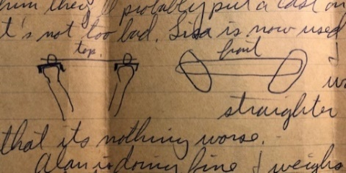

Dad draws a picture.

Alan is doing fine and weighs 8 lbs 5 oz so has gained that much from just under 7 lbs. Ruth is real happy and the Dr. said he seems to be doing so well that she can just about forget about the bottles. We were home yesterday afternoon although Lesle and I went to get some turpentine just before supper. Yesterday evening Lesle and Lisa played in the basement while I put the first coat of paint on the chests. I’m not quite sure I told you that the first two chests that came had damaged places so we sent them back to Speigels (Chicago mail order house like Sears and Wards). Two new chests came last Thurs and they were in much better shape. I had planned to put the next coat of paint on today but won’t get to since we’re going out to the Lesters.

Dr. Abood agrees with me that I should stay here at least 2 years. That’s the way I answered the letter about a vacancy in Washington. Mrs. L didn’t see much of Chicago but thought she could get around OK if she were here awhile. We really haven’t just driven to see things at all. When the days are longer and warmer we’ll get out more. As I may have said our $40 gas bill covered from the time we rented the house the first part of Oct thru Dec I think, so that didn’t seem to bad.

Ruth made herself a birthday cake and I’ve promised her a sweater and slip as soon as we can get a Sat babysitter and get out. We mailed a birthday card to M.J. yesterday. The girls enjoy TV – we select the programs of course and I think it’s quite educational even at Lesle’s age.

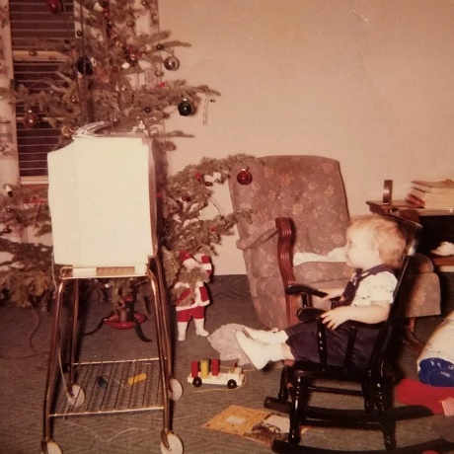

Lisa enjoying TV - December 26, 1960

We put the old living room carpet and pad, it had a corner cut out for the furnace, in the basement for the girls to have their toys on. I stacked the empty cardboard boxes around its edge and Lesle uses it for a “play house.” Alan’s hair is dark brown and he’s lost some of it, I guess. Come when you can. As I said once, we can get to Madison in 3 hours, I’m sure, on the tollway, etc. Glad to hear Aunt Clara is settled and you can send this on if you like. Well the girls are up now so we’ll have to get ready to go.

**2-2-61** – Mom writes – Dear Aunt Clara, I’ll write a little while the girls are “reading” and Alan is napping.

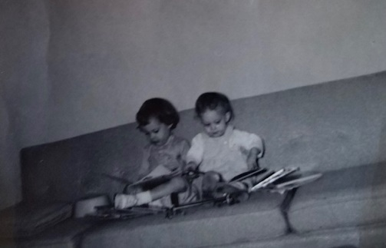

We took Alan to the orthopedic surgeon yesterday (same one we took Lisa to). We’re supposed to exercise his feet for three weeks and see if we can avoid having to put casts on his feet. Dr. West says this is not a serious problem, but is one of the most common and is due to his position before he was born.

We took the girls to get their shoes checked while we were out. Carroll tried to check Lesle’s shoes before we went and she objected, saying “You’re not a shoe man – you’re just a man!” Both girls had to have shoes and Lesle has graduated to brown and white saddle oxfords now. They both got bright red balloons filled with helium so they’ve had a lot of fun with them.

Lisa has finally decided it might pay to talk, so she’s been adding quite a few new words to her vocabulary. Her latest additions are “man,” “cow” and “ointment.” We were very pleased when we took Alan for his 4 week check-up. He’s gained almost a pound and a half over his birth weight and had grown ¾”. The doctor was so satisfied that she said to not even think about a bottle or solids for at least another month, if then. So all he gets is juice (1 oz once a day) and vitamins (extra that is).

Carroll’s going to take me shopping for my birthday present Saturday. He’d promised I could choose my sweater as soon as we could go shopping without any youngsters along. It will be nice to go out just once just the two of us. Time to fix lunch, so I’d better stop. Write any time you have the time.

**2-5-61 – Sun afternoon -** Mom starts the letter - I’ll write at least part of this and let Carroll add whatever he wants. Yes, my fork came – I thought Carroll had said that it did. I’d been waiting to write until I found my list so I could tell you how much silver we have. We have one complete place setting (knife, fork, teaspoon, soup spoon, salad-dessert fork and butter knife) and 3 settings of knife, fork, teaspoon and salad-dessert spoon, plus 3 extra teaspoons.

We got a sitter yesterday afternoon and had a childless shopping trip. We went to Elmhurst and picked up Lesle’s new shoes (we had to leave them to have the pads put in, but we got them fitted Wed). Then we got my birthday sweater and slip and the material for the curtains in the girls’ room. We stopped at the grocery store, too, and let me just look around a little. The sitter got along o.k. and the kids were perfectly happy when we got home.

Carroll and the girls went to church this morning. They got stuck coming in to park in front of the house, but managed to get out alone. Alan is having a fussy spell. Maybe he just doesn’t want to sleep. He’s getting so he’s awake for longer periods – as long as 4 hours sometimes. And he’s relatively happy for most of the time. He’s finally beginning to have some sort of schedule. He usually eats about 8:30 PM, goes until 1:00 and then is up again at 5. During the day he’s still pretty erratic.

Lesle’s quite proud of her new brown and white saddle oxfords. Both girls had to have a full size larger than they got just before we moved. We had their feet checked Wed when we were out anyway for Alan’s appointment with the orthopedic surgeon. The doctor said Alan’s problem was a common and not too serious one caused by pressure on his feet before he was born. Anyway, we’re supposed to exercise his feet and try to get them softened enough for the special shoes. If they aren’t soft enough in 3 weeks, he’ll have to wear casts for a while. Alan needs some attention now, so I’ll let Carroll finish.

Dad takes over. We had a 7 inch snow early Fri. I stayed home in the morning and painted on the chests. The main roads were in pretty good shape by the time I left although the side streets stay pretty bad. I’ve gotten stuck in front of our house a couple of times. Speaking of insurance we just renewed (3 yrs) our personal property insurance $79 for $6800 valuation, this was less than we paid for a smaller amount 3 yrs ago.

The trip to the Lesters went fine and the girls were very good. Alan ate more than he ever had before Mom writes in above that: (we think). Back to Dad: She had a meat loaf dinner and we visited awhile before coming home. The girls enjoyed the boys’ electric train in the basement. Bill said his Mother was now in Texas. I finished painting the chests yesterday morning so we can finally begin to get the girls’ room fixed. I guess we haven’t done anything else other than the routine. Ruth had a thank you from M.J. yesterday in the same mail with your letter. Our TV is a portable and on a metal stand with wheels – like yours, I guess. I guess that’s about all the news so Lesle and I will go mail this if the car doesn’t get stuck! You can show this to Uncle Clyde, MJ and Bill, and send on to Aunt Clara if you like. Dad writes *Lisa* twice in his closing, scribbles one out, draws an arrow to the scribbled out Lisa and writes: Lesle bothered me.

**2-14-61 – Tues 4:00 PM –** I’m at home early today since I have to take Ruth back down to the hospital for her final 6 wks checkup. As you remember, her Dr. sees some of his patients at the hospital. We have a baby sitter coming at 5:00 so I won’t have 3 to take care of in the hospital waiting room. The total hospital bill of $353 was all taken care of by Blue Cross. Since it was costing us about $105 a year we have more than received what we put in - Lisa’s bill was all taken care of too. Ruth’s room at Presbyterian St. Luke’s was $29 a day even though it was semi-private. Nevertheless, all the facilities were of the highest type.

Ruth is going to a meeting of the Le Leche League this evening. That is a group of women, it was organized here in Franklin Park, who meet periodically to discuss the problems of breast feeding. The girls and boy are still asleep so I’m having no difficulty with this writing. However, as soon as they get up they’ll be right in on top of me.

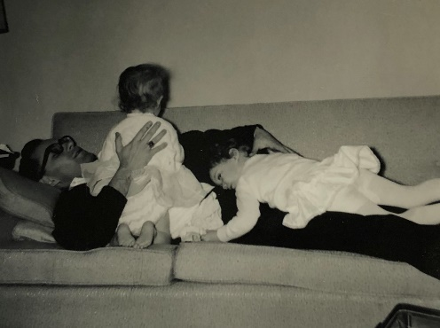 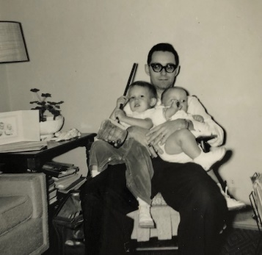 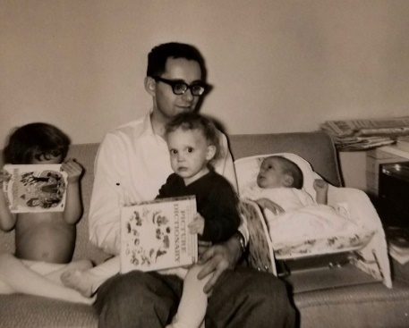

The girls and boy right in on top of Dad.

We all say “Thank You” for the nice valentines which we received from you today. The children had some from Aunt Clara yesterday – she enclosed a note.

I must get the income tax return off. With the extra exemption for 1960, (Alan!) and with the fact that part of my 1960 salary (government fellowship to the K.U. Dept. of Pharmacology) is tax exempt, I should not have to pay any 1960 income tax. I had about $350 withheld so should get it all back. My present fellowship is tax exempt so is actually worth more when you figure that you don’t have to pay any tax. If I stay a 2nd yr the fellowship would be $7000 and a 3rd yr $7500. That’s as much or more than I could possibly get in an academic job.

My research has been largely negative so far, but that’s the way research goes. I have learned some new techniques, and have done a lot of reading, so the time has been well spent. By the way, I am not doing work on Chicago Public Health – as it stated in the church bulletin. I have a United States Public Health Post-Doctoral Fellowship. These are given for 1-3 years to PhD’s and MD’s in the medical sciences; anatomy, physiology, pharmacology, etc. My sponsor is Dr. Leo G. Abood who (has a PhD in pharmacology from the University of Chicago – like Dr. Walaszek) is director of the neurophysiology (physiology of nervous system) research labs in the Dept. of Psychiatry at the University of Illinois. Some of the work is with patients, but my work is very basic and deals with the effect of drugs (especially those that cause hallucinations) on chemical processes of muscle and nerve.

Last Sun morning I took the girls to s.s. while I went to church. We were home the rest of the day. Last Sat I finished painting the knobs for the girls’ chests. Ruth is finishing their curtains so we’re about to get their room in shape. We were home Sat afternoon except for a brief trip out to mail some letters and leave a bank deposit. The bank has a place to put mail deposit envelopes. In the evening we had a girl from across the street baby-sit while we went to the couples club at the church. They had their regular dinner and then a program with a Valentine’s Day slant. It reminded me of the Valentine banquets you used to have and which you often talk about.

The last few days have been warm and the snow is all gone. Ruth and the children have taken walks the last two days and this noon they ate across the street at the Slocums’. It is their granddaughter who babysat last Sat night. The granddaughter and her mother live with the Slocums. The Slocums are members of our church but do not attend regularly.

I don’t know what kind of transformer our TV has. Our antennae is “rabbit ears” type and pulls up and out. I dress warm for cold weather but it would be bad to have car trouble on Congress since might have to walk some distance. We’re at the hospital now and I’ll mail this here. Hope everyone is fine there and of course you can send this to Aunt Clara M.J. and Bill, as you like.

**3-1-61 – Wed 4:10 PM -** I’ll start this while I’m still at work and finish it after I get home. I use an old dresser with a mirror for my desk. Its in a little room just off the big lab where I work and is out of the line of traffic so I can get quite a bit done. I had a nicer desk in Kansas City ha!

No Dr appointments this week but Alan has a checkup on Sat. He seems to be doing nicely and is sure a lot fatter appearing than when he was born. He’s gradually going longer between feedings but still gets up once or twice at night. Although the Dr. hasn’t suggested it yet, Ruth is trying a few solids to see if he’ll go longer. Babies really don’t need solids till around 6 months but most Drs. start them earlier. He doesn’t seem to mind his shoes and we think his feet look straighter already. Lisa is walking much better and doesn’t fall down as much. She’s getting to be quite disobedient at times – typical for her age, I guess. Lesle has “regressed” somewhat since the new baby but is generally doing quite well. She has learned pretty well that we select the TV programs she can watch and how much she can watch. Occasionally, she turns it off herself.

I’m home 6:00. The weather has been wonderful recently and we certainly have no complaints. It rained a little on the way home this evening. The girls play outside some each day and it helps to work off some of their nervous energy. We plan to take our drivers license tests soon, probably next week. Lisa has now crawled up on my lap so it’s becoming difficult to write.

Last evening the insurance man brought Alan’s new policy by. We bought him a $5000 policy from Northwestern National (the same company, Carlton Armour, that my first policy was from). It has an option so he can buy up to $30,000 more insurance when he is older (I’m now holding Alan) – without medical examination. From now on, now that we have all the insurance we need, we hope to start saving so that by the time I take a more permanent job we’ll have enough for a down payment on a house.

Mr. L goes back Mar 31st for a checkup (Denver) – they think they got it all OK. (got what?) Mrs. L has had a lot of pain and a recent checkup showed that her ulcer had healed but scar tissue was obstructing the opening out of the stomach. She doesn’t know yet if they’ll have to operate. They still plan to go to Tokyo, leaving around the 20th of May. I had a note from Ted Addleman today saying he could use me from May 20th to 28th. If I do that we’d come on to Hutchinson and stay till commencement time, probably June 4 & 5.

I have a paper at the Federation meetings in Atlantic City in April and we may all drive. Last Sun morning we all finally made it to church. Alan was real good and only let out one peep – during a quiet time, of course. We picked up hamburgers afterwards, just like we used to do in Kansas City. We stayed at home the rest of the day. I like to watch some of the Sun afternoon TV programs.

We stayed in most of the day last Sat, did some cleaning etc. I have been vacuuming on Sat mornings. We didn’t have any more snow as you had heard predicted. Hope Jimmy is feeling better now and I hope you got over your upset – don’t worry too much about Aunt Nellie – you’ve certainly done all you could. Why don’t you try to sell the apartment, although I suppose you’re clearing some money now that the’re all rented?

Our car stood out in the weather in Kansas City (on Eaton). It doesn’t seem possible but it’s almost 4 years old. I have a big shovel but have only used it once. You can send this on to Aunt Clara, MJ and Bill and tell all hello.

**3-8-61 – Wed 7:00 PM –** Its Wed again and that’s when I’ve been writing your letters recently. It snowed some this morning and is now snowing again this evening. It hasn’t been very cold so the driving hasn’t been too bad. I guess this same storm was in Kansas and Nebraska.

I think the Federation meetings are April 10-14th, so any time before that is fine for your coming. I’ve never driven down to Dearborn Station, where the Santa Fe arrives, but I’m sure it won’t be too bad. The traffic is lightest on Sun and probably next lightest on Sat, so arrival on Sat or Sun would be the easiest to meet, and maybe the whole family could go along. Lisa is on my lap with one of the new books. The gifts arrived today and Lesle says “thank you.” Ruth says a link or two should probably be taken out of the bracelet.

We’re all recovering from a round of colds. The children had it the worse. Lisa got up yesterday morning with a fever and sore throat so we had the Dr. out. Our Dr. is a lady and apparently makes house call. (!) Our neighbors pediatrician will not make house calls. She gave Lisa some penicillin and she is feeling much better today. Lisa seems much more susceptible to colds than Lesle, and Alan is starting out more like Lisa. Lesle has been coughing some also but has not been clear (I’m holding Alan) down like Lisa was yesterday. Alan has the sniffles most of the time and we use the vaporizer at night for all of them. Ruth felt sickish today so I guess it’s finally our turn after having been so lucky all winter.

Mon night we had a nice birthday dinner for Lesle and then she opened her presents. She got some toy kitchen utensils, books, new shirt and of course enjoys her new tricycle immensely. She even sits on it to watch TV. When she’s over her cold she’ll use it in the basement and soon it’ll be warm enough to take outside.

Our neighbors have been down with cold and flu for some time, also. Mon morning we had Mrs. Slocum from across the street babysit (she’s a great-grandmother) and we took our drivers tests so Ruth can legally drive again. Mr. Slocum is a retired railroad man and shoveled our walks this morning. On the way home from the driver tests we got some new material to cover the rocker and for living room curtains. Sun morning we stayed home from church because of the colds. Ruth made a rabbit shaped cake for Lesle that evening.

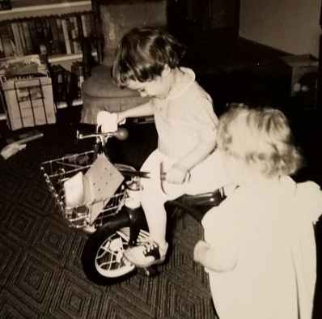 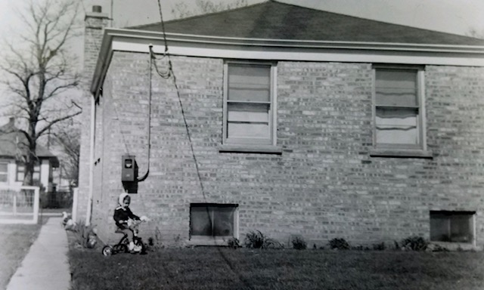 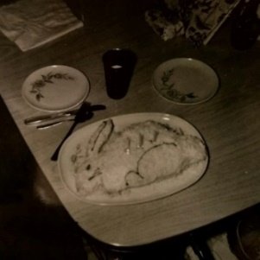

Lesle’s new tricycle (inside and outside), and her rabbit shaped cake.

Sat morning was the Dr. appointments for Alan and Lisa. Alan weighs 11 lbs and gained almost 3 lbs in the last month. His feet are definitely straighter.

Had a card from Aunt Clara today saying she was starting back the 10th. Hope you’re feeling fine and tell all hello. I promised to work for Ted Addleman from May 20th to 28th. We’ll go to Hutchinson right after that and then on by Lawrence for commencement June 5th. That will give almost a week in Hutch. The public health service says no more than 1 month vacation – ours should run about 3 wks.

Congratulations to M.J. and Bill. We all trust that things will go smoothly this time. I guess we’ll have to take the baby basket back to Kansas. Alan still uses the basket during the day but has outgrown it already for night (uses the cradle). Don’t know whether Aunt Margaret is home.

**3-15-61 – Wed 10:10 PM -** We were glad to have your mid-week letter today. I’ve been writing your letters earlier than this on Wed’s, and then taking them over to post office. Since you don’t get it on Thurs, I’ll wait till morning to mail this, and maybe you’ll get it on Friday, as usual. This morning I found that one of our car’s tires was flat so I had to put on the spare before going to work. I must have picked up a nail somewhere, although it was OK when Ruth went to the Le Leche (breast feeding) meeting. It sure makes it easier for her to have a license – and I don’t have to act as “chauffeur.” The meetings start at 9:00 PM, so the ladies can get their children to bed, and last about 2 hours.

Today was warmer so Ruth let the girls outside for the first time in a wk and half. Lesle enjoyed riding her tricycle outside for the first time. Lisa had her usual fall, and got another bruise. She was riding her horse with wheels. The girls are just about over their colds but mine was pretty bad Mon morning so I stayed at home and rested. I got some paper work done. My cold is better but still bothers me. Ruth has been the most well of all, although she’s had some.

Lisa and Alan have their feet appointment the first week in April. Lisa is definitely walking much straighter, and doesn’t fall down as often. She doesn’t mind the splint, but it sometimes catches on her bed and awakens her earlier than we would like. Lisa is always the first awake, usually about 6:30. Lesle gets up around 7-7:30. Alan hasn’t slept clear through yet, but is usually up only once during the night. He is gaining real well and his sniffles are somewhat better.

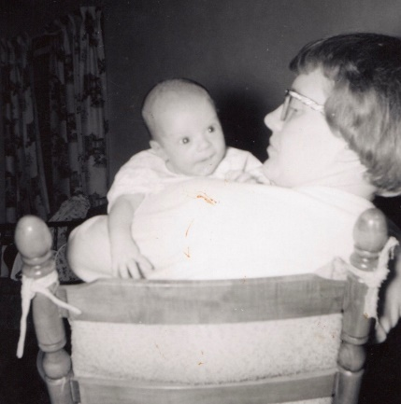

Alan at 2½ months.

Sorry you decided not to come now but do as you feel best. Your schedule of meetings and things must keep you quite busy, and I imagine your schedule will be lighter later. Mr. L will be through here April 30th on the way to a meeting in Ithaca, NY. He’ll just have time to stop one day and we’ll plan to have Alan baptized at that time. Come that week-end if you’d like. Glad to hear that everyone is fine and that Aunt Clara got home OK. I guess I still get notices from Green Lake. Sometime we’ll rent a cabin there and take the family for a vacation. I was forgetting that you wanted to go to Madison when you come here. In that case the week-end you mentioned might be best. If you wanted you could stay a day or so extra in Madison and then come back by here. We could drive up without any trouble as the weather would be warm by then.

We had a letter from Mrs. L today. She had an allergic reaction to a drug, but the eczema is better and she can now eat more things. Her mother has been sick and is losing interest in life. She has so many responsibilities that it would be hard for her to get away this spring. Last Sat evening we hired the baby sitter across the street and went to the couples club at church. They had a smorgasbord. We went by someones house before coming home. The program was a man who sculpts. We missed church on Sun because of the colds. Yes, we gave Lesle her tricycle. Lesle’s card came on her birthday and the package 2 days later. Trust M.J. is feeling OK. I hope everyone else is also. (Thurs morning) is cooler this morning but clear. We have many more cloudy than clear days. You might write Mrs. Ring. We would have to stay in a motel there or at K.C.

**3-25-61 – Wed 1:45 PM –** I’ll start this while I’m still at the building and finish it after I get home. I have to leave shortly as Alan has his second appointment with the Dr. to see about his legs. Ruth applies outward pressure on his legs everytime she changes his diaper and we will find out today if doing that will be sufficient or if he’ll have to wear a cast. Other than that he is doing fine. We think his profile looks like “Mr. Magoo” (cartoon character). He supports himself and holds his head real well, also. Lisa is talking a lot more and climbs on and into everything. The girls have been getting outside during some of the recent warm days. The last couple of days have been colder after a spell of real spring-like weather. Unless we have a lot more snow I’d have to call it a mild winter snow-wise but, of course, much colder than Kansas.

We were sorry to hear about Aunt Nellie but it is probably for the best. Mr. Laidig recently had a skin cancer removed from his face and went to Denver last week-end for x-ray treatment to make sure they got it all. (ah) He was to go for another treatment yesterday, I believe. They hope to come sometime this spring for Alan’s baptism. They leave for Tokyo the latter part of May, if the’re feeling OK (Mrs. L’s ulcer still bothers), so, as I may have previously said, we’ll plan our vacation around that time. We’ll probably go to Oberlin first and then by Hutchinson and commencement at Lawrence. We have offered to keep Danny or Deloris (preferably her) while the Laidigs are gone. Feel free to come here anytime, applies to M.J. and Bill too, we have plenty of room.

I’m (we’re) now at the Drs. (4:15) so I’ll continue. I just called about Blue Cross transfer. As I told you we got complete coverage on Alan. The University of Illinois plan is with another company so I may have to transfer. We were home most of the time last week-end. Sat afternoon Lesle and I went to a little children’s shop and got Lesle a new snow suit (separate). Its size 3 so she can wear it next year also. She’s been wearing the coat and it makes her look older. Ruth and Alan just came out of the Dr.’s office and he won’t have to wear a cast but will wear some special shoes which we’ll go get now.

Just finished supper after having gotten his shoes ($14). I guess I’ll wait awhile for my new pair of shoes. We all went to the grocery Mon night. We stayed home from church last Sun since Alan was whezzy and Lisa had a runny nose. I’ll take this over to the post office tonight but you probably won’t get it tomorrow because of the strike. I know how the magician does most of his big tricks and illusions but his slight of hand is pretty good. Tell all hello and you can send this to Aunt Clara and M.J. and Bill. Alan seems fussy because of his shoes (he’ll wear them 24 hours a day) and will probably be up a lot tonight. Mr. Laidig has a big write-up in Kansas Administrators’ Journal sometime.

**3-30-61 – Thurs 8:00 AM -** Well, I guess it’s letter time again. We were glad to have your letter last Sat, I believe. The last few days have been a little cooler, but not cold and the girls played outside some yesterday. The nearby children seem pretty nice and they get along OK. They play with the children to our South but we have never met the parents. Their name is Johnston. The’re a little bit older than we are while the Gerdings, to the North, are just about our ages.

This Sat we may take a train and go downtown to see the Easter windows. When we were here for the meetings last year we saw some animated easter bunnies in the windows of one of the big department stores. Lesle should get a big kick out of them. It will be very crowded since it’s the day before Easter. Sun we’ll try to make it to the early church service and then go to the Lesters in the afternoon. Aunt Margaret will be there.

Alan is doing fine and now smiles for daddy, as well as for mama. He smiles a lot for Lesle. He has quite a double chin and his legs are getting fat, this is so noticeable since he was so skinny at these two places when he was born. When he’s not hungry and tired, he’ll content himself for long periods of time. He and Lisa have appointments next week for their feet – maybe they won’t have to wear their special shoes any longer.

We hope M.J. is getting along fine and you may let them read this. I’m still not clear about the’re not having their house rented? Is Bill going to summer school, school next winter, or what? Univ of Wisconsin? We’re not sure yet whether Deloris Musgrave will be here in June or not. Dave Musgrave is getting married July 1st. Dallas is the one here and Don teaches school at Elkridge, Kansas.

Lesle (and Lisa too) has done the dishes, she begged us until we finally let her, without coaxing, the last three days. She stands up in a high chair and it gives her a chance to get in water.

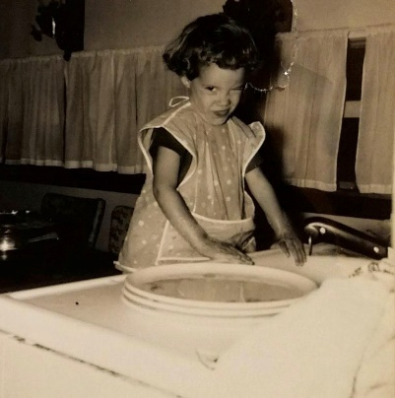 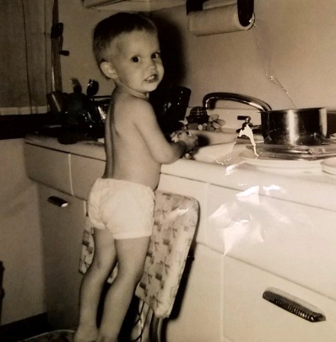

The girls love to play in water and sometimes mess up the bathroom when they play a little in the bathroom lavatory. We plan to leave here about Fri the 7th for the meetings. There is turnpike most of the way so we hope to do it in two days. We have friends in Pittsburgh which is a little more than halfway. We may try to go by the Laidigs first since Judy (one at KU) will be home that weekend. We listened to Billy Graham on TV last Sun afternoon. We all made it to church last Sun. Alan was still whezzy but is better now. Last Sat morning we went shopping in Elmhurst (South and West – where orthopedic Dr. is) and ate at a café at noon. We left Alan with Mrs. Slocum. It was warm. Glad to hear about Richard Searl. I’m not sure that we tried to send them a Christmas card.

**4-1-61 – Thurs 7:45 AM –** I’ll write a short letter before going to work. I guess that even an airmail letter takes 2 days to go from here to Hutchinson. That last one you received on Sat was mailed here on Thurs morning. We were glad to have your card yesterday. It is cloudy and cool again today – the last few days have been damp and cool, so the girls haven’t been outside much. We’re all practically over our colds, although I still have a little.

Ruth and the girls made cookies yesterday and in the evening took (Ruth and Lesle) some over to the Gerdings (North). Mr. Gerding (Bob) – about my age – Mrs. graduated from college in 1956) was gone so they stayed till about 9:00. Alan ate some orange juice before they got back. Alan is doing real well and has gained more than the girls had at this age. Of course he’s a boy and should be larger and taller. He seems to be bigger boned, also. He still eats every 2-3 hours during the days and gets up at least once a night. If he has a bottle he wants to eat every hour. His legs look perfectly straight. I guess not all Drs. recommend the shoes and splints at the early ages – waiting until they’re about 3 to see if they straighten out. Nevertheless, I guess it can’t hurt and is easier now than later.

No, I did not mean that April 21st would be too soon after our trip, so plan for then if you’d like. My paper at the meetings is the first day, April 10th at 1:30 PM. We’ll leave here Fri or Sat and depending on what we hear from the John Laidigs in New Jersey, will either stop at their place on the way or drive up from Atlantic City on Tues or Wed. We have motel reservations at At. City for the 9th-12th. The meeting lasts through Fri but we can’t afford to stay that long. Ruth could handle the children alone OK but it would be quite a task – we’d have to have enough food so she wouldn’t have to go out any. However, she’s been tied down pretty much here so is looking forward to a change – even with the children. I almost went to Atlantic City one other time as you may remember.

Mrs. L writes that she can’t leave Oberlin before the Tokyo trip so she won’t be here that time when Mr. L comes. Her Mother was in the hospital awhile but has nothing seriously wrong, considering her 94 yrs. She’s been depressed and irritable, which is typical for her age. I think she’s always had good spirits every time we’ve seen her. Mrs. L’s brother-in-law in Florida (where grandmother went earlier this winter) is pretty bad off with his eyes and has been in the hospital 4 months. He can’t see at all at present. Mr. L resigned for next year.

I kept Alan last Sun and Ruth took the girls to church. Last Sat Ruth went shopping and in the afternoon we all drove to the lab so I could pick up a paper. Ever since we were there (Lesle had never been there) Lesle has been wanting to go to work with me. Right now she’s helping to wash the dishes – unbreakable of course. Tell Aunt Clara, Uncle Clyde M.J. Bill and Jimmy hello. Is Bill going to school in Madison next year. Hope you’re all OK. Mom adds: Lesle and Lisa helped dye ‘blown’ eggs for the Easter egg tree and both girls fingerpaint now.

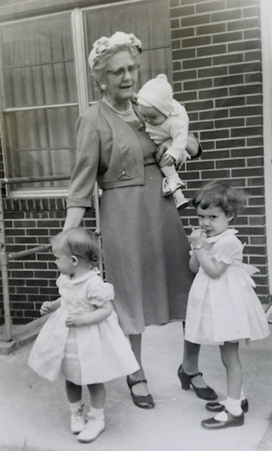

Sunday, April 23rd. New outfits from Grandmother.

**5-9-61 – Tues morning -** Everything’s been fine here since all the grandparents left. (There for Alan’s baptism I assume.) We had a letter from Mrs. L yesterday saying that she had a good trip home and was busy as usual. We hope you had a good trip to Newton and on home also. Mr. L phoned Mrs. L from Lake Placid and insisted he was feeling better. Nevertheless, we wrote Mrs. L to have Mr. L have a thorough eye examination. Double vision, etc., can be a symptom of many things, some of them serious. You and Aunt Clara take care of yourselves and get lots of rest.

Our Mother’s Day gift to you will be a Carroll Alan disc for your bracelet. However, since we don’t know the exact type of engraving why don’t you have it made and we’ll pay you for it. My check came last Sat so you can send that check through any time.

The weather held until yesterday when it finally rained. That was about the longest stretch of good weather we’ve had. I guess there have been a lot of storms down your way. We’ll be home this week but will probably go to couples club this Sat night. Sun afternoon is an open house at David and Jan Clarks. She is a school friend of Ruths and the’re both from Roanoke church in Kansas City. He is graduating from McCormack Seminary in Chicago.

Last Sun we all went to church and in the afternoon I helped on the calling for a capital funds drive for Presbyterians in Ill. I guess we didn’t do much last Fri and Sat. Our plans are still to leave about a week from tomorrow as I explained to you. Tell Aunt Clara and Uncle Clyde hello and we hope M.J. is feeling OK.

**5-16-61 – Tues –** We may hear from you today but I’ll write this first. We plan to leave around noon tomorrow and will go down 66 to Springfield and then 36 all the way to Oberlin. We’ll stay in a motel. 36 goes thru Seneca you know. Our car is a red and white 2 door 1957 Ford. We’ll have the first class mail forwarded. If anything comes that looks important call us in Oberlin at Grover 5 – 3187 – (new #) or mail it if you think it would arrive by a week from Sat. Haven’t heard from KU yet. See you soon.

**5-20-61 – Sat –** From Oberlin - We arrived here OK late Thurs night. Good trip but girls always get restless. Alan was real good. It’s 820 mi. here so is almost as far (900 miles) as to Atlantic City. Has been cool and rainy all the time since we left. Had your letter here and your plans sound OK. I’m working now and will work all next week. We’ll leave a week from tomorrow unless the Eldon Laidigs can come down from Colo. We might have driven out today with Mr. and Mrs. L if I hadn’t had to work today. The’re driving on to California and will leave by plane the 25th.

**5-25-61 – Thurs –** Had your letter. Everything is fine here. I’ve had to do some extra work since one of the girls has been sick and the older Mr. Addleman (Dot – 87 yrs) is in the hospital. We visited him and he seems to be better and hopes to get back down to the store.

Lesle has been going to bible school in the morning. Has been cool most of the time but is warmer today and was clear yesterday, also. Eldon writes that they’ll come down this weekend so we probably won’t leave until Mon. I’ll need to see Ted for my money. We may go to Norton Sun to see great grandmother and Uncle Edgar. We saw gt gr here before she went over there last Sat. We’re not sure about Jetmore yet. The Laidigs fly from San Francisco today.

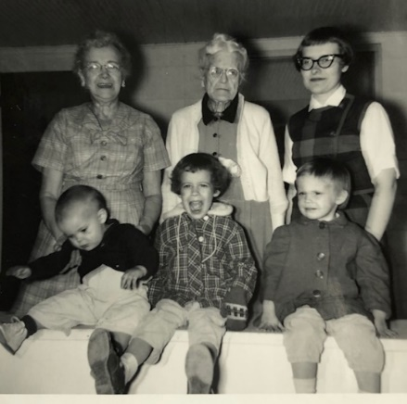

Four generations in Oberlin.

**6-5-61** – Dad participates in commencement exercises in Lawrence. He doesn’t write about it because Grandmother is there in person.

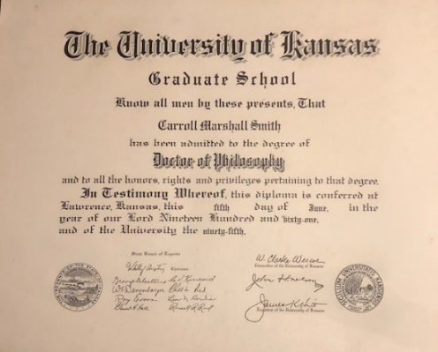

**6-7-61 – 3:45 Tues –** I’m writing this just before we get to Monroe City, Mo. Lisa’s fever continued last evening but she is more like herself today. She ate a pretty good lunch when we stopped at Brunswick, Mo. We plan to go all the way today unless we get too tired. From Springfield, Ill it’s 4 lane so it won’t be bad at night. Lisa doesn’t have any fever now.

**6-8-61 –** Its cooler this evening after rains today. Lisa is fine now but I have some cold. We’ll plan to leave in the morning after I go to the building a bit. We’ll stop in a motel and won’t drive any more at night than we have to. The rehersal is 9:30 Sat morning and the wedding (Dallas’s) at 4:30. We’ll drive back Sun. Ruth is finishing the girls’ dresses now.

Glad you could come to Lawrence and I’m sure it would have been hard on Aunt Clara and M.J. and Jimmy. We missed some rain on the way up and had no trouble. Stopped in Springfield Ill for supper and kids slept last part of way. Ate lunch in Brunswick, Mo. Got here at midnight. Went to work yesterday and today. Everything the same here and tell all hello.

**6-13-61 – Tues 2:00 PM -** Happy Birthday! We have a birthday present, but you have something similar, so I’m not sure how we’ll work it out. Thanks for sending my check on. The mailman thought I should have notified him (I’d never done it before when I checked the card for temporary change of address) when we got back so he continued to forward mail after the date (5-31) that I’d said to stop on.

Last 2 days have been very hot but Minneapolis trip wasn’t bad. The girls didn’t walk down the aisle despite my coaxing. We went over and saw the Searls on Sun morning so that made the trip more worthwhile after the girls “failed.” Dallas was glad we went, however. We left Fri afternoon and got in at 11:30, stayed in motel. Spent Sat at Carol’s house (bride) and then out to a small town near Searls where we stayed in a lady’s room. As usual got back with $1. I’ll write more later.

**6-17-61 – Sat noon –** Today is warmer after our cool spell. The girls slept later on the cool mornings, but were up early this morning. They go to bed about 9:00 since it stays light longer, and that makes them sleep a little later.

Went to the Dr. last Mon and Alan needs to wear his shoes all day/night for another 6 weeks. We may have to buy some new shoes (special) as he’s about to outgrow the old ones. Lisa is back on her splint for a while longer, also. It bothers her some at night and one hot night she was up several times. My very first memory is of lying in a crib in the dark, with a light shining somewhere off in the distance, as if from a hallway, and I am awake, and I cannot move my legs, and I do not like that I cannot move my legs.

We’ve been home this morning cleaning house for company this evening. Dr. Al Poisner, MD (from K City and worked some with Dr. Walaszek) is finishing his internship and will be leaving, so we’re having him and another fellow (just got his M.D.) and his wife out for supper. This fellow got a masters under Dr. Abood. We finally got the pictures (girls etc.) up in the living room. Dallas Musgrave took this week off so we haven’t seen them since the wedding. We want to have them out for a meal also. I suppose you’ve sent my check thru. My money is now in to cover it. Tell Aunt Clara, Uncle Clyde M.J. and Bill all hello.

**6-29-61 – Thurs AM –** Trust everything is OK there. Last night was the hottest in a long time and Ruth was up 7 times, 3 with Alan. Our bedroom is on the NE and it doesn’t get much breeze. Alan sees the Dr. Sat so she may have some suggestions. He hasn’t started meat yet and that should help.

We were getting anxious about the Laidigs on Mon when we didn’t get any mail, so Ruth called them up. They had just been home 2 hours and had a fine trip. They sent us a cloisonné Jap-plate with basketry which they bought in the factory.



The cloisonné Jap-plate to which Dad is referring. Photographed by Lesle in 2019.

They took their time driving back from San Fran and stopped at Grand Canyon, Carlsbad etc. The photographer was here yesterday with some proofs of the children and we’ll send you a picture of the 3 together later. The man was here to fit the slipcover for the platform rocker. It will take 3-4 weeks. Ruth is starting on the new curtains. Dallas called and they may come out this weekend. When we get the slipcover and curtains we may have some more company. Haven’t done much else this week. How is M.J., and what have they heard about a place to stay in Madison. Any of you are welcome to stay here any time as you know. Show this to Aunt Clara, Uncle Clyde, M.J. and Bill.

**7-5-61 – Tues AM -** We’re spending a leisurely 4th at home this morning. It rained some last night and this morning after being quite dry. Sun and yesterday were cooler also. Sat we worked around the house and Dallas and Carol Musgrave came over for supper. They didn’t stay very late. It was hot so Dallas and I carried up the air conditioner. It still works OK and will help on the real hot days, especially when feeding Alan, etc. I don’t believe as many people have air conditioners here as in Kansas, so it may not get quite as hot.

Sat morning Alan had an appointment, he’s 25½ inches and 16 # 2 oz. He had a shot and was feverish later in the day. We missed church Sun morning since he was still irritable and the girls slept very late. Church is at 10 now. Sun was very relaxing and the girls took long naps. In the evening we played some badminton with Gerdings. Alan got so fussy we finally had to stop. We took a long walk yesterday evening as it was so nice and cool. We may go out later today to eat at a drive-in. Alan only got up once last night so I guess there’s hope for his sleeping through.

The Laidigs sent some Jap-Kimonos to the girls, and a colorful outfit for Alan. I wrote, I guess that they had a fine trip and are home OK now. We ordered Lisa’s bed on credit from Wards, but haven’t heard from them yet. We’ve never had any credit other than from Mobil Oil Co. Glad to have your letter Sat and to hear about everything. Glad to hear that M.J. and Bill have rented their house OK. Our coffee maker doesn’t work right either. You can pass this on to all the others.

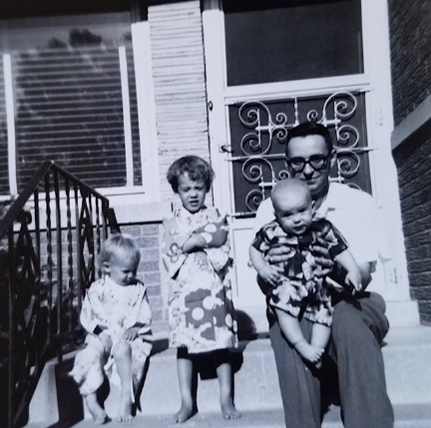

The Jap-Kimonos for the girls, and colorful outfit for Alan. On the front steps of the Franklin Park house.

**7-8-61- Sat 4:00 PM –** It’s a little warmer today although still on the cool side for this time of year. I don’t believe we’ve had the air conditioner on all week. I’m sure we’ll have plenty of hot weather before the summer is over, however. I guess Chicago weather is about like Kansas’s – unpredictable. I mowed some of the lawn yesterday evening and it was real chilly.

I feel today like I might have a touch of virus, kinda tired and achish. My check came today so Ruth went to the store for groceries as we were quite low. The girls are just now getting up from long naps after having gone for check-ups and polio shots at 12:15. Lisa didn’t cry at all and Lesle only a little. Lisa is practically trained except for BM’s. We started putting training panties on her about 2 weeks ago and she has responded quickly. She just came in to tell me that she got up dry from her nap.

Sun 4:30 – Just after nap time again. The kids all got up earlier this time and are quite fussy, so they probably should have slept longer. We may go out for a ride after supper tonight. It is warmer today. We all made it to church this morning and Lesle went in big church for most of the service. Yesterday we went out shopping after I stopped writing. We stopped for hamburgers at a drive-in and brought them home to eat.

Glad to have your letter yesterday and to hear the news. Had a long letter from Mrs. L, also. The’re quite busy as usual. Mr. L has been cleaning out his office at school and setting up a little office in the little house out in their backyard that he uses for a workshop and storage. He is adjusting insurance (farm crop hail losses, etc.) also, like he usually does in the summer. His official Rotary governorship duties started July 1st. He has to visit every club in his district at least once during the coming year.

Danny Musgrave is working some on a farm and stays out there most of the time. I’m not sure that I told you that Danny, Deloris, Don and David Musgrave were all at Dallas’s wedding. We had thought at first that none of them would be able to make it. The Gerdings (our neighbors to the North) are taking a vacation in Minnesota next week.

Mrs. L is busy with the yard, flowers, etc. She tapes radio programs on flower arranging for a radio station in Colby. They are starting to ask them for programs on their Japan trip already. They don’t have their slides back yet, however. Our pictures haven’t come yet. Grandmother came back home from Norton (she was staying with Uncle Edgar (Mrs. L’s brother) and Aunt Dova) shortly after we left Oberlin. I guess she is feeling better these days.

We bought Corning Ware for Bob Legg’s (Ruth’s cousin in K City whom we used to see) wedding present, and for Dallas and Carol Musgrave, also the same for Mrs. Moyes in Kansas City. We sent Mrs. Moyes a handle for her dish just recently. They were so good to put us up when we were moving and this last trip also.

It’s now 9:30 – We just got back from visiting some church friends after having taken a ride. Not much special on for this week – I have my papers to fill out for a renewal of the fellowship for a 2nd year. The way things stand now I’ll stay till a year from Sept. 1st at least.

Glad that M.J. and Bill rented their place. What have they heard about a place to live in Madison. I don’t think you should mow the yard, why don’t you hire it done. Mr. L goes out on wheat losses like Willetta and Beebe’s. When I worked in Sterling 4 years ago this summer, just after we were married, Mrs. Crebbs came in the store, once, I believe. She was quite crippled. I, of course, remember several visits at their house.

Our grass is greener after some recent rains, it had really gotten dry. Glad that you have the apartments rented again and can afford some repairs. I’m not sure that I wrote that we stayed home most of the 4th, going to the drive-in and for a short ride in the evening. We’ve driven around quite a bit now, but not much down in the city or in the southern parts. Show this to Aunt Clara, M.J. and Bill and Uncle Clyde if you want.

**No Date – Wed 9:00 AM –** I’m at home this morning while the car brakes are being relined. The original brake linings had lasted almost 35,000 miles so I guess that wasn’t too bad. The brakes were holding OK but were squeaking a little and might not be safest for a quick stop at high speeds.

Our weather has been chilly the last few days but otherwise fine. The girls have been playing outside quite a bit – there are a lot of neighborhood children. We’re going to buy some clothesline posts for the back yard. With the warmer weather Ruth wants to hang the clothes outside. It will save running the expensive electric dryer so much.

The car will be ready at noon and I’ll go on down to work then. Mr. Slocum (across the street) wants to ride as far as the driver license place. I’m running experiments, today and tomorrow, like the ones I did last in Kansas City. I need some information for the paper at the meetings. The paper is on some of the work at Kansas City.

Alan is doing fine and looks so fat for one of our babies. He’s not large, of course, compared to most babies. We hope to be back in time for the Dr. appointments a week from Sat for Alan. Alan and Lisa went to the Dr. yesterday afternoon. Their feet are much better, but he said for them to wear the splint and shoes a while longer. They will go back in two months. We’re all over our colds now. One of the fellows at the lab, who also has three children, said they had quite a siege of colds this past winter, also.

Yesterday morning I went to work but I came home early so I could get the oil changed in the car and we could get away in time for the Dr. appointments. Sun morning we all went to church. Alan stayed in church awhile but got fussy and had to be taken out. Ruth finished two turquoise and white gingham dresses in time for them to wear to church. Ruth is making a culotte for herself now.

Sun afternoon, after we’d all had naps, we went out to the Lesters’. Aunt Margaret was there and got to see Alan. She said for you to try and see her. She’ll not be moving till May 1st so thought maybe you could see her before then. We might be able to drive you to her place, especially on a weekend. You might write her some possible plans. You’re welcome to come back here from Madison and then on to her place later, or as seems best. The Lesters had company for supper Sun so we left after not too long and stopped at a drive-in on the way home.

Sat morning we took the Milwaukee Road commuter train downtown; we took the girls but left Alan with the Slocums. I’m not sure whether any trains from Madison stop here or whether they all go through Milwaukee and come down near the lake. Its 14.5 miles from the station here downtown. I drive 17.5 miles to get not quite as far. We saw the animated easter bunnies in the windows of Goldblatts – we had seen them last year when we were here. We went in Marshall Fields and Carson Pirie Scott also. We ate lunch at the drug store cafeteria where we had eaten during the meetings last year. We were all tired when we got home but I guess it was worth it.

Last Thurs night we all went to the church service. Alan was good and stayed in the service. The girls were the only ones in the nursery. We didn’t feel we could afford a sitter that time.

We plan to leave here as early as possible Fri. We’ll get on the tri-state tollway not too far from here and take it to the Indiana border. Then the Indiana and Ohio tollways across those states and hope to make it to Pittsburgh by that evening. We will stay at Carol and Jack Duvall’s, 1640 La Salle Ave, Pittsburgh 16 Pa. They are moving and their phone has been disconnected. Sat morning we leave on the Pennsylvania turnpike (it goes from the state line to Pittsburgh also) and follow it to Harrisburg where highway 22 will take us the rest of the way across Pa., across New Jersey and practically to the Laidigs at 178 Meyersville Rd, Chatham, NJ.

Sun we’ll probably leave in time to make it to Atlantic City before dark. That route is down the garden state parkway. My paper is Mon afternoon 1:30 and we’ll be leaving Wed or Thurs morning, probably Thurs if the money holds out. At Atlantic City we’re at the Continental Motel, Illinois Ave at the Boardwalk, Ph 5-5141. Coming back it looks like 322 and 42 to Philadelphia 43 to the Pennsylvania Turnpike and then on to Pittsburgh where we might stop at the Duvalls or a motel. The rest of the way will be the same as going.

We were glad to have your letter and cards last Sat. Thanks for the gift. Trust M.J. is getting along fine. I infer that Bill may be going to school in Madison this summer or fall?

Unless you hear otherwise I’ll meet you at the Dearborn station. About 40-45 mins drive down early in the morning but I’m not sure of the parking so you just wait until I arrive. Driving on to Madison that day, and coming back Sun sounds OK to us. When you come back to Chicago I could run out from work and get you and you stay at the building until I’m ready to leave, if its during the day. That will all work out someway. Cabs would be too expensive. Shouldn’t take over 4-5 hours to drive to Madison.

You can show this to Aunt Clara, M.J., Bill and Uncle Clyde and tell all hello. Looks like Grandmother added the following: (I sent the card to be sent back to me. They airmarked it, I guess and I received it yesterday.)

**No Date – Mon AM -** Glad to have your letter Sat and to hear about your birthday. I mailed yours and Aunt Clara’s gifts on Sat. If your spoon is just like the one you already have you could exchange with Aunt Clara, if agreeable to both. Has been cool and enjoyable weather recently – not hot at all.

We all went to church at 10 AM yesterday morning and were home the rest of the day. Did jobs around the house Sat. Ruth went shopping in the afternoon. Alan still gets up once or twice, usually twice, at night. He eats lots of solids and is sure growing. Lisa and Lesle enjoy playing with the neighbor children. We got a new glider for the swing set in the backyard. The old glider is partly broken.

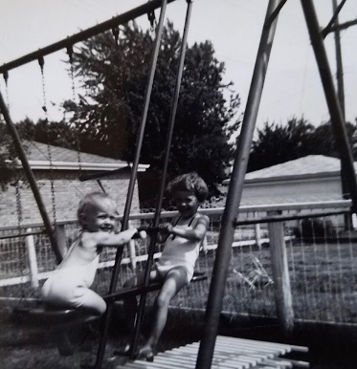 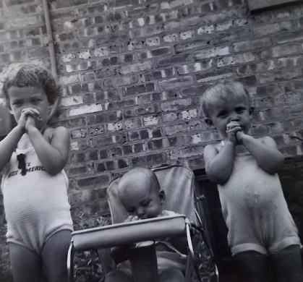 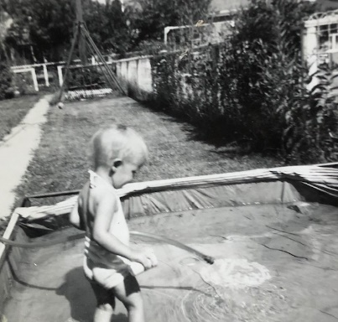 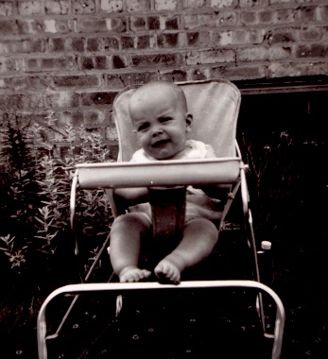

Summertime in Franklin Park

Fri night we ate with a group at a restaurant and then to an outdoor tent theater “in the round” to see “South Pacific.” Had Mrs. Slocum from across the street to babysit. We were home most of the time last week.

My work is going fine. Should have a paper on it before long. I’m starting working on writing up some more results from my thesis. May go to the fall pharmacology meetings in Rochester NY the last week in Aug. You can share this with Aunt Clara, M.J. Bill and Uncle Clyde. We have new material to slipcover that old platform rocker in the liv room.

**7-18-61 – Tues Morning –** I’ll write this before I go down to work. We may get a letter from you today; we received your card last Sat. Yesterday was warmer and we had the air conditioner on last evening. We turn our fan on in the girls’ room to help them get to sleep. They’ve been sleeping pretty well, recently. So far our weather hasn’t been as hot as we’re used to in Kansas. It is about as humid, however.

Alan is still a “little pill” and gets up at night. Last night he cried himself to sleep after having been asleep, following eating in our bed. He was up twice in the night so we’re tired this morning. He eats his meat and solids real well, but they don’t seem to make any difference. I guess we were just spoiled by the girls sleeping through early – some just don’t sleep through, as early. He gets enough milk at night, as it doesn’t matter whether he’s had a bottle or not. He doesn’t have any teeth yet so Ruth is still feeding him almost entirely.

The pictures haven’t arrived yet but should any time. The KU chair hasn’t come yet, either. We’ve had to delay ordering the “hood” because of lack of money. We’ve never received our $350 income tax money back. They said we were being audited so I guess we’ll hear someday.

Wed Morning – Didn’t get this finished yesterday morning. We’re watching TV on the space shot, but it doesn’t look like it will take place now. Carol and Jack Duvall, an old Oberlin (Carol) school friend of Ruth’s who has lived in Pittsburgh, PA, is moving here shortly. Jack is a United Air Lines mechanic and will be out at O’Hare field. We stayed overnight at their house in Pittsburgh on our way to Atlantic City. They were here a week ago looking for a house to rent and finally found one yesterday. They’ll be several miles from us. We had them for dinner a week ago tonight and they’ll be over Sat also. Houses to rent are very hard to find so I guess we’re lucky. Plenty to buy if you have the down payment.

Alan did better last night, up only at 2 and slept later this morning. It is cloudy and rained some this morning and there aren’t as many jets so that may be the reason he did better. The jets are so loud in the summer when the windows are open etc.

Last Sun we all went to church. Lesle stayed quiet all through the big service. Our pastor is on vacation so we have a substitute. We ate drive-in fare afterwards, Sun and then were home in the afternoon. In the evening we drove to Evanston to visit Helen and Al Metcalf. He’s a government lawyer downtown and was formerly in Oberlin. Helen has had multiple sclerosis for 3 yrs. but it is in remission now and she feels pretty good. Afterwards we visited Helen and Dale Johnson (they live only a few blocks away), also formerly of Oberlin, by the time we got home it was midnight.

The girls were up late last Sat night also as they were watching our neighbors to the South put up a swing set. We have finally got acquainted with the people there, but we had to make the first move. She’s about my age and he’s a little bit older. The girls have played with the children all summer.

Last evening we went for ice cream (Dairy Queen) cones and then took a ride. Alan had a little tiny baby cone and made a mess. Afterwards I mowed some and Ruth visited the Johnstons (South). Our neighbors to the North are gone on vacation this week. The pictures will come on Thurs and we’ll get yours off as soon as we can.

We enjoyed having letters from you and Mrs. L yesterday. Everything about the same in Oberlin. Their slides came and they’ve been out talking several times already. Lisa is doing very well on her training, she got up dry this morning and has used the stool both ways already. She is about 10-11 months ahead of Lesle so we can’t complain at all.

We got our Wards credit card but haven’t heard about our order for Lisa’s bed. We want to establish good credit so we’ll have references for the future (loans etc.) We have good credit with Mobil Oil. We invited Helen and Dale for supper a week from Sat. Tell Aunt Clara, M.J. Bill and Jim Hello.

**7-27-61 – Thus AM -** As usual, I’m slow getting around to this. However, we did get your picture off which you should have by the time you get this. Lesle is sober, but that’s about all you can get of her in a picture. We have individual ones of each also.

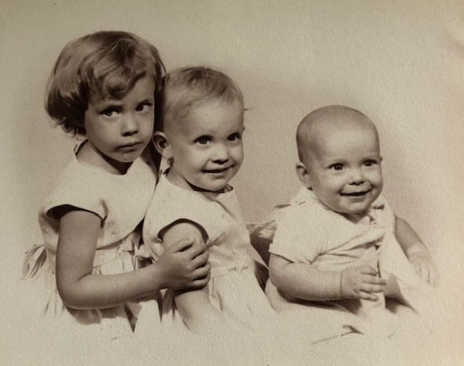

We were glad to have your recent letter and to hear that everything is OK. This morning is cloudy and cool. Its been warm recently but not as hot as usual. First July in 20 yrs that there hasn’t been a day over 90 degrees by this time. We only need the air conditioner in the late afternoon and evening.

We have lots of flowers; most of them were already here but Ruth planted some of them. Ruth has a few plants of vegetables, also, but there isn’t much room for them. We ate outside last evening using the lawn chairs of yours and the girls’ new little picnic table. Their table came without some of the screws but they can use it some until it’s all fixed.

We ordered a matching bed (I’ve written this) for Lisa from Wards but it was out of stock and will not come till after the first. It’ll be on credit. There is a pole lamp in the Speigel catalog like we want, so we might establish some credit there also. Ruth has finished that quilt she was doing by hand and has a good start on the curtains. The curtains, pole lamp, and new cover for the couch will just about finish all the fixing up we want to do at this time, and all we can afford too.

I sent in my renewal for the fellowship yesterday but it will be sometime before I hear. My work is going OK. I found a way to drive down that is 1½ miles shorter and doesn’t take much more time. I always knew it was there but just hadn’t driven over it.

We took a long ride last Sun evening across the North part of Chicago and by that covenant school, North Park College (where Dallas and his Carol went) then on down the North Lake Shore Drive, (you don’t see the lake all the time) down North Michigan Avenue (fancy stores) and back out Congress and home the new way. We try to take a long ride about once a week.

Carol and Jack Duvall found a house (Ruths high school friend). They were all over (4 children) for hot dogs last Sat night. My KU chair came last week and is certainly nice.

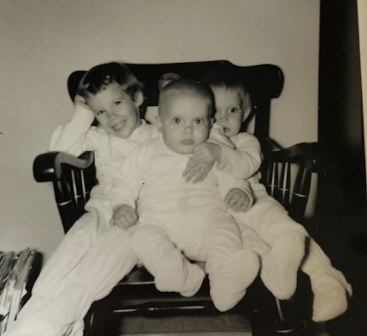 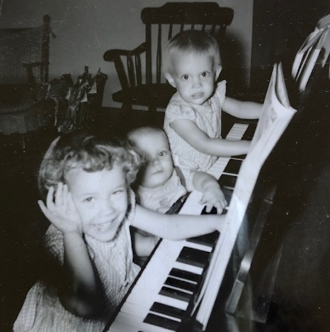 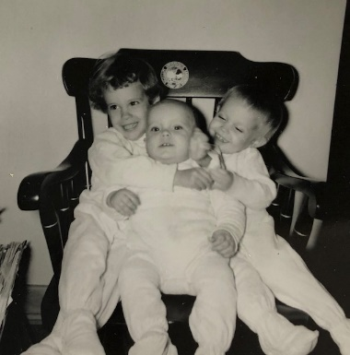

Piled on the KU chair. Also, KU chair in back of the three piano players.

It is early American and therefore, will fit in with the scheme of Ruth’s. It only cost us the $6 freight and would easily be worth the $36 it sells for. Since the living room would be too crowded with the chair in it the way it was we moved the bookcase into the yellow room (where you slept) and put the new chair and Ruth’s rocker at the east end where the bookcase was. I think the room looks much more roomy. We really have enough furniture for a larger house. We spent last Sat moving the furniture and cleaning before the Duvalls came.

We were all tired Sun morning so stayed home (?!) and Ruth waxed the kitchen and we caught up on odd jobs. Helen and Dale Johnson (former Oberlin people) whom we had invited for next Sat night can’t come, so we may have someone else. Lisa is doing very well and has few big accidents. Alan still eats like a pig and is sure fat (for us).

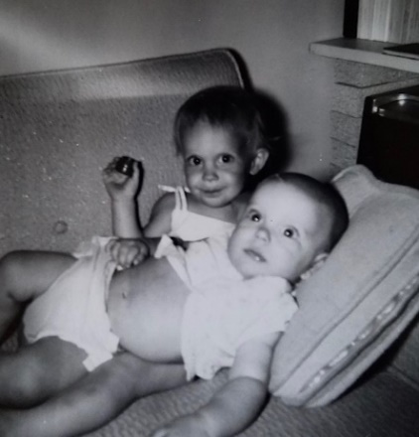

Lisa with ‘fat’ Alan.

He’s doing a little better at night; the jets are so noisy they help to prevent sound sleep. The girls go to bed around 9 and get up about 7:30. The Gerdings to the North, got back from their vacation yesterday. He has 2 wks, I believe. We went out for ice cream cones and Alan sure liked his little tiny one and he really made a mess. Show this to Aunt Clara, M.J. and Bill and Uncle Clyde.

**8-23-61- Wed AM -** I’ll write this before I go down to work as I didn’t get it done last night. The girls are still asleep – Lesle just walked in. It was hot last night and none of us slept too well. Generally we can’t complain, however. The summers here are definitely a little cooler than Kansas. Alan is still eating like a pig and usually gets up at night. He says “Ma-Ma” real well and “la-la” and “da-da” occasionally. He gives no indication that he’ll crawl and will probably be like Lesle in that respect. Ruth still gives him milk and will probably continue until time to switch him right to a cup. He drinks real well out of a cup now. Lesle is about the same and eats some better. She and Lisa have enjoyed all the neighborhood children this summer and are quite gregarious (?!). They always want to take walks when mommy and daddy are tired, but we usually give in. Lisa caught her head between the front porch railings yesterday and, of course, was quite subdued afterwards.

Mrs. L and Grandmother did not come by here. Mrs. L apparently took her to Indiana, as we tried to call her at Oberlin at the time she would be gone, and they said she was in Indiana. You see we weren’t positive that Mrs. L would be driving her back. Anyway, Mrs. L went on back to Oberlin without coming by here. Ruth tried to call her long distance last night for her birthday but our phone is out of order. Our area code for direct distance dialing is 312 (GL-1-1859 = our #) but I doubt if could call that way yet.

Dr. Abood leaves today for 6 wks of traveling in Europe and then to Japan. Some sightseeing and some meetings I guess – Dr. Abood is 10 yrs older than I. I haven’t heard about my 2nd yr application but I should get it. I’m making no plans to go to the Rochester NY fall pharmacology meeting the last of this month. I sent Ed an abstract for a paper but it was too late as he was out of town when it arrived. I would need to give a paper to get travel money. I hate to leave Ruth with the baby, so tiring, etc. and several people will need my help while Dr. Abood is gone, so it doesn’t look like I’ll go.

We went for groceries Mon night. Sun night we went to Grant Park (just East of loop on lake) and listened to one of the free outdoor summer concerts at the band shell (pianist with orchestra). We were all on a blanket and the children were fairly good. Sat morning we went to get the girls new shoes and shop. We ate lunch at a restaurant and the girls were real good. We went over to Carol and Jack Duvall’s (friends just here from Pittsburgh) one evening last week. Glad to have your letter Mon. You and M.J. and Bill know you’re welcome to come here at any time. Show this to them and Aunt Clara and Uncle Clyde. Glad to hear about your trip and everything. Glad Uncle John car works OK. Mom asks: When do Mary Janet and Bill leave for Wisconsin?

**No Date – Sun afternoon -** I’m quite slow in getting this written and I have no real excuse. (Except for three babies, a wife, a house, and a job ☺) Glad to have your letters and glad you got the picture. We like it, also. We haven’t mailed the Laidigs similar picture yet. The company is one you make an agreement with and they come out to the house at specified times. Its easier to get a good picture in familiar surroundings. We had a very hard time in Kans. City when we went to the photographer’s. We plan to have a similar picture for our Christmas cards.

The temperature has been in the 80’s most of the time here so it hasn’t been too bad. It gets quite humid however. Hope it hasn’t been too hot for you there. We’ve had quite a bit of rain the past week which has helped to make it cooler also. We went to church this morning. There was only one helper in the nursery so Ruth helped after Alan started crying shortly after we left the room. Alan is growing and has two bottom teeth. The first one came through yesterday and the second one today. He has slept through occasionally at night when he didn’t sleep much during the day. He just got up now (4:15) from a pretty good nap. We may go by a Le Leche League (breast feeding group) picnic after awhile.

I think I wrote that Alan and Lisa have to wear the shoes and splint for a few weeks more at least. Alan has occasionally said “dada mama and lala.” We stayed home all day yesterday and worked around the house, read, etc. The living room curtains look nice. I think I mentioned that we plan to get a pole lamp for the living room. Lisa’s bed hasn’t arrived yet but may this week. What’s the latest about M.J. and Bill going to Madison. Come and spend a few days now, when they come, or whenever you want. Maybe we can all have Christmas here at our house this year. Before the weather gets bad we’ll be able to go to Madison. Mrs. L may take Grandmother to the Williams reunion in Indiana sometime this month and might stop by here a bit.

Fri night we drove to Waukegan to visit Rev. and Mrs. Moyes (K.C.) at her sister’s. They are on their vacation and were on the way to Wisconsin. Waukegan is a far north suburb and we drove over 80 minutes there and back. The girls were tired yesterday. Mrs. Moyes sister is a singer so she and I both sang a song together with Ruth playing. Yes, Lisa’s birthday is Sept. 9th. I’ll get to the clippings one of these days. You may have read that we had a milk strike here for a couple of days. Dallas lives near where he used to, by North Park College where he went to school awhile. Dallas hopes to go back to college next spring. We’ve eaten outside several times using your chairs and the picnic table.

**8-24-61 – Thurs morning -** I’ll write this before I leave for work. I just don’t seem to get to letter writing in the evening anymore. The last few days have really been cool and it seems just like fall; it rained some yesterday morning and the girls had to stay inside. Had a long letter from Mrs. L yesterday and she doesn’t think they’ll try to come by here when Mrs. L drives back to get grandmother. G is getting more confused but stood the trip back to Indiana OK. I don’t know if we’ll try to get down there to see her, or not. It would be more of a drive than Madison, but not like Minneapolis.

Tomorrow night we go over to Carol and Jack Duvall’s for supper and we may go bowling with them one evening next week. I believe there’s a Dr. appointment this Sat with the pediatrician. Ruth’s ear had been hurting so I came home early Tues and we went to a Dr. Her ear and throat looked normal so the hurting may be from a wisdom tooth. It’s been some better with aspirin and the heating pad but she’s to go back in 3 wks since she has a little hearing loss, as measured by the instrument. I think I have a little loss in some ranges, myself. She thought it was a recurrence of her middle ear infection that she had so bad in Kans. City one time, and when she was on penicillin for a long time. I occasionally get ear and eustachian tube congestion, but seem to stay free of bad infections. As you know you have to watch throats and ears so carefully with children. I guess my ear was drained once when I was little? We all need to go to a dentist.

Yes I suppose I should have tried to go to the meetings but I have been a little disappointed that Walaszek never writes me after I write him. He told Leo over the phone that he might put my name on one of his papers but if he did he’s never sent me a copy. I sent him my corrected thesis paper 2½ months ago and I’ve never heard one word about it from him. He has two post-doctorals there with him and they both have several papers in print or work done after mine was completed. Without a paper I didn’t think I can get travel money and we don’t have the cash to spare right now. Dr. Walaszek may show up this week here.

Last Sat we took some of our trading stamps (outlawed in Kansas) and got a piano lamp and a letter holder planter combination. They both are nice and the planter helps to fill up the bare east wall. We had a vacuum cleaner salesman out Tues night but we had to say no till possibly around Christmas. Our old tank cleaner is 20 yrs old and is borrowed from the Laidigs. After I hear about next yrs fellowship we’ll feel easier about finances. I claimed all of my withholding back $350 and finally had a notice last Sat for an appointment about it. I had sent them all the information I had and so I called and the’re to check in to it. I hope we get most of that back. These fellowships are largely tax exempt.

We went to church last Sun. Lesle stayed in big church most of the time but got fussy and had to leave. We are going to try and sing in the choir this fall. It will mean hiring a regular babysitter one night a week. Lisa slept in her new bed last night and Alan in Lisa’s old bed in the yellow room. Alan didn’t sleep too well. Glad to have your letter this week. This letter is for all – Aunt Clara M.J. Bill, Uncle Clyde. Hope MJ and Bill get moved OK and we’ll see you all sometime.

**8-31-61 – Thurs 6:00 PM -** Dear Aunt Clara, My usual yellow scratch paper is all used up so I’ll have to be more “formal” this week (white typing paper). You can pass this on to Mother to read like she does with my letters to her – let you read them. We were glad to have Mother’s letter yesterday. The last few days have been our hottest stretch after having a relatively cool first part of Aug. It’s cloudy now and may rain tonight. I don’t think it rains quite as much here as in Kansas. Our yard is getting dry again after having greened up following a previous wet spell. Alan is sitting by me as I’m writing and is trying to get the pen. He has been pretty fussy recently and we think he’s getting some more new teeth. He got his first 4 all at once and sure likes to chew.

Its after supper now and it rained and blew while we were eating. Our air conditioner has sure been a big help; it only cost $50 (bought it last summer from some friends who were going overseas for a few years), so I guess we’ve gotten our moneys worth. We’re wondering this evening where M.J. and Bill are. If I were driving from Kansas to Madison I would probably come this way because of the 4 lane highways, but they probably angled off over a shorter route. If they come this way they can easily call us from the tollway (Ill.). We’ll want to see them as soon as we can, but won’t impose any on M.J. because of her condition. You and Mother will have to fly up sometime while we’re both so close together. We’re only 10-15 minute drive from O’Hare Airport, where all the jets land. Many of them go right over our house and (changed pens) interrupt conversations and TV. We’ve certainly enjoyed the TV which was possible because of your Christmas gift. It gives Ruth a chance to relax when the children get too trying. Ruth’s ear is better – I wrote Mother that it didn’t appear infected.

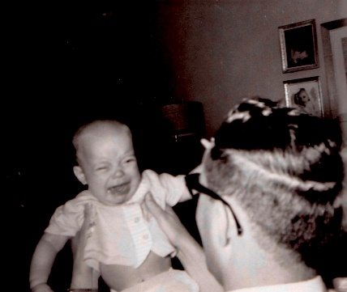 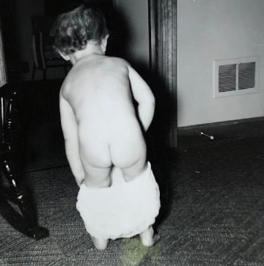 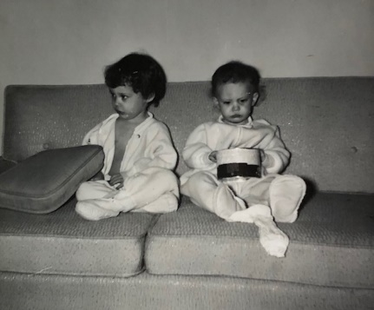

The trying children.

Alan and Lisa had check-ups last Sat and Alan weighs as much at just 8 months as Lesle did at a year. They have appointments for their legs and feet Sept. 5th. We’ve been lucky and thankful the’ve been as healthy as they have. We’ve invited the Lesters over for dessert a week from tomorrow night. We haven’t seen them since when Mother was here. Choir practice starts next Wed night. Ruth has said she’ll teach a s.s. class (1st grade) so she may not sing regularly since s.s. is during church hour. We all went to church last Sun morning. We were going bowling with some friends this evening but he (Jack Duvall) had some foot trouble, so we’re all staying home. We went over to their house for supper last Fri night and the men babysat (they have 4 children) while the women did some shopping.

I took yesterday off and we all went to the Brookfield Zoo. We didn’t begin to see all of it – I expect it’s one of the largest in the world. It was real hot and we ate lunch there, coming home by 2:00 so the kids could have their naps. Ruth’s mother leaves tomorrow to come back to Indiana to get Ruth’s Grandmother (95 yrs old) and take her back to Kansas. They do not plan to stop here. Mr. Laidig is busy as Rotary Governor and giving talks. Hope you’re fine and not too hot and that we’ll see you sometime. I don’t know about any Christmas plans yet. Glad to hear the news from Mother etc. I didn’t have Miss Parker for biology – I had Mr. Sesher. Guess that’s about it.

**9-9-61 – Sat 8:30 AM –** We’re staying home this morning so I’ll write this now. I meant to get it off yesterday. The last few days have been quite warm, but not unbearable. Lisa says “thank you” for her card yesterday and we were glad to have your letter this week, also. When are you planning to come, before or after the baby is due; also, when is the due date? We need to take the baby basket up for them and could take you up at the same time. Let me know as soon as you can when you’ll be here so I can make plans for meeting you. I would think M.J. would want the basket before she goes to the hospital. If you don’t plan to come before we’ll run it some weekend by ourselves.

The Lesters and their boys were here last evening for dessert. Ruth served raison crunch topped with vanilla ice-cream. We hadn’t seen them since you were here. They had all been in New York for one of Bill’s meetings and he had been gone for some other meetings this summer, also. I told them you’d like to see them when you’re here, if you have time. Aunt Margaret’s address is 1527 Niles Avenue, St. Joseph, Michigan. My check hasn’t come for this month yet – it usually comes on the 7th. It makes it hard to plan ahead when you don’t know when it will arrive. We had good financial news, however, the treasury dept checked over my income tax return and I will get all the withholding back ($350) that I claim. I thought surely I would, but you never know about the government. Most of it will go into savings.

We ordered a tricycle for Lisa’s birthday and also an end table, with a drawer, from Wards. They were supposed to come by yesterday but didn’t, so we’ll delay Lisa’s celebration until it comes. Ruth is baking bread now and will make Lisa a cake. We decided on the end table, early American style, rather than a pole lamp for now. We need some more drawer space for odds and ends. Mrs. L took Grandmother back home from Indiana and said she stood the trip fine. We’re sorry we weren’t able to see them but it just didn’t work out that we could. The Laidigs are busier than ever.

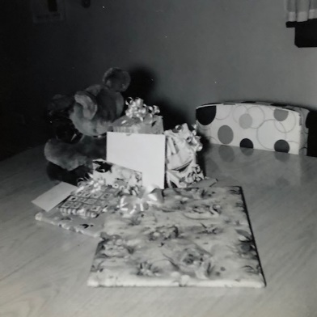 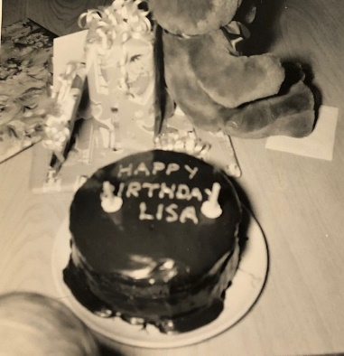 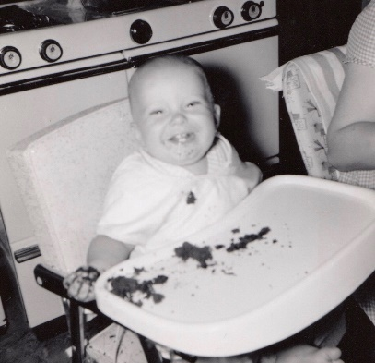

Lisa’s 2nd birthday. Alan enjoyed the chocolate cake.

Dr. Walaszek stopped by last Tues. We were both waiting on each other. I sent him back a corrected paper shortly after our vacation and he claims he never received it, and I’m positive I mailed it, so apparently it was lost on the way. I kept wondering why I hadn’t heard from him about it, and he was wondering why I’d never sent it back – all this waiting for over 2½ months. I told him I would stay here till a year from now. The department in Kans.City is all off with Dr. Peters, and most of them will be leaving as soon as they find satisfactory jobs elsewhere. **Henceforth**, there will probably be a job available there in about a year, but I’m not sure that I would want to work for Dr. Peters either. He has a very “strong” personality and if they don’t agree with his decisions he gets off with them. I guess he wanted to be dean of the medical school when Wescoe left to become chancellor, but he didn’t get it and has been hard to get along with since. Dr. Walaszek is definitely planning to leave as soon as he gets a job elsewhere. He said he talked to Dr. Wenzel and Dr. Smissman (from pharmacy school) and they are trying to get rid of Dean Reece since they don’t feel he is giving them proper support. They are applying for money to set up a new graduate program and would need another pharmacologist. I told Dr. Wenzel once I would be interested. Dr. Walaszek, of course, wouldn’t recommend it all because being in a pharmacy school pharmacologists have a harder time getting membership in the society, and a harder time getting grant money. The salary would be less than a medical school but if it comes through I’ll consider it.

I went to choir practice Wed night and Ruth had a s.s. meeting Thurs night. She is teaching the first grade s.s. class and starts tomorrow. Lesle starts s.s. for the first time, too. A week from tonight we’re having Helen and Dale Johnson for supper (former Oberlin people) and a week from Sun is a church retreat. Next Tues is Ruths ear appointment. It hasn’t bothered her much recently. A week ago this morning we all went down to Presbyterian St. Luke’s for Ruth’s obstetric check-up (6 month – she was late). We had to wait 3 hours since her Dr. was delievering and were starved and tired when we got home. We all went to church last Sun and they recognized the s.s. teachers.

Glad to hear M.J. and Bill got to Madison OK. I guess we’ll have to write them separately now since I’ve always assumed you gave my letters to them. I had Miss Ely for Jr. English but like most of high school I only remember about one incident in her class. I just didn’t care about such things at that time. I remember my magic perfectly.

Alan is fine and is sitting by me now. The plane (not jet) crash was 2 miles from Bill and closer to her mothers. It was the worst ever in Chicago. This crash happened September 1st out of Midway. The crash wiped out four entire families, one of them with seven members. 78 people died. It was, at the time, the deadliest single plane disaster in U.S. history. There was another crash on September 17th. This time a partially filled jet out of O’Hare. All 37 passengers died. Our little family was living under the flight path of all those planes. Yes, Elmhurst is close and is where the foot Dr. is (we went last Tues and Lisa doesn’t have to wear the splint anymore unless she gets worse later. Alan still wears his shoes for a while.) Elmhurst is where you went with us for that car bed. We buy shoes there and go to a book store there also. Hope you and Aunt Clara and Uncle Clyde are feeling fine and we’re looking forward to seeing you.

**9-?-61 – Wed AM –** I’ve waited to write this until after we heard from you (yesterday). Today is cloudy and it may rain. We’ve had several days of clear weather after our stretch of rain from (hurricane) Carla (We have a girl in the neighborhood named Carla who is rough, also). It was colder during the rainy days, also. We have a pipe that we have to put in the basement drain so that sewer water won’t back up in the basement. In an earlier rainy spell we failed to get the pipe in and we had a lot of water come in. This time we had the pipe in but it rained so much that we had a lot of water from seepage through the walls. The sewer drains into a nearby river and the water level is very high. This time a lot of my books and magazines got wet, although the file wasn’t hurt. The rug and pad were completely soaked. With the help of the neighbor men we got the rug up to the backyard where it dried out. The pad is still wet and in the basement. We lost half of our good cardboard boxes.

Tonight is choir practice. Not tonight but next week, I’ll pick up a lady who wants to sing but doesn’t like to go out alone at night. She will go herself on Sun mornings. She lives in Franklin Park. Quite a few of our members live here even though the church is in Elmwood Park. Yesterday evening we all drove out to pick up the $10 registration fee that Ruth had paid to take an evening adult course in knitting. There were not enough enrolled so they had to call it off. Ruth has always wanted to learn to knit and was looking forward to the course. They give a whole series of evening courses at East Leyden High School (in Franklin Park). The plan was for Ruth to go to that on Tues night and I’d go to choir on Wed. At first it was scheduled for Wed so we would have had to get a babysitter. Now Ruth may go to choir practice some on Wed evenings even though she can’t sing on Sun. Mon evening we hired the girl across the street and went bowling (Lisa just asked “How’s this?” and Lesle answered “All right, dear.”) with Carol and Jack Duvall. We had planned to go earlier but Jack had a bad foot. Although we don’t do too well we like to bowl occasionally.

The plane crash last Sun was about 2-3 miles from here. About the same distance the other one was from the Lesters. The road near the crash was all closed to keep away the curious. Nevertheless, there was a lot of traffic in the area when we went to a church retreat in Bensenville that afternoon and evening. A lot of the people were late because they had to be rerouted. The retreat was from 4-8 and we hired the girl across the street again. Ruth took salad. The retreat was for officers, teachers etc. I’m not anything but it was OK that I went, especially since they didn’t have a very big crowd. There was an afternoon meeting, a pot-luck supper and an evening communion service.

Our income tax refund came so we’ve been getting a few things we needed. Ruth and the children have walked to the post-office a couple of times to buy saving stamps. Their first bonds are from you of course. Sat I worked in the yard and we had Helen and Dale Johnson for supper in the evening. Fri night I put the kids to bed and Ruth went shopping with Carol Duvall. They have 4 children so the women like some child-free shopping occasionally. We registered to vote Fri evening also.

Last Tues Ruth went to the Dr. and he said ear was OK but to come back in 4 months. Wed night Ruth enrolled in the course and I went to choir practice. Thurs night we all ate at a nearby pancake house and then did some shopping. A week ago Sun we all went to church. Ruth gets along fine with her s.s. class and Lesle likes hers OK, but I guess she doesn’t say much.

I think I wrote a wk ago Sat. We may go to Madison this Sat and take the baby basket whether she wants to use it or not. The only basket Alan had (went into a cradle later) was that one. I’ll meet you at that train (just wait if I’m not right there) unless I hear otherwise. We might take you up then – we’ll see what works out. I told the Lesters we’d drop by there a min. Tell Aunt Clara and Uncle Clyde hello. We’ll write M.J. and Bill.

**9-12-61 -** Mom to Grandmother – Dear Mother, Lisa’s package arrived yesterday. Her dress is sweet and is not too long, but I’ll have to make the shoulders narrower – she’s very slim for her age. She’s wearing her watch and enjoying everything in the package. She says “thank you.” The rest of us enjoyed our parts, too. The tricycle hasn’t come yet, but Wards is working on it. She enjoyed her birthday. We ate at a drive-in and then had her cake and presents afterward.

It’s raining again – it’s rained nearly every night for a week and has rained off and on all day. Lesle says she likes the thunder now, but that when we lived in Kansas City and she was just one, she cried. Alan eats mostly table food now. He loves to chew, even though he only has four teeth. He doesn’t crawl, but he gets around by either rolling or sitting up and wiggling. Must write a quick note to my mom, too, so I’ll quit for now.

**10-2-61** – Mom writes – Dear Mary Janet and Mother, This will be short since the postman will be here any time. We just wanted you to know that this Sat (the 7th) is a bad day for us since Alan has a doctor appointment at noon – so we hope you can stay till the next Sat so we can come get you.

As usual, it’s cold again, but the girls wanted to go out anyway. They’re invited to a birthday party Wed, which means I’d better get busy on the present.

In case you’re wondering why this is disjointed and hard to read – it isn’t easy to write while you hold a baby and stand at the window to keep an eye on the girls. (The city just graveled the alley and the kids have discovered that the rocks are wonderful for drawing on the sidewalk, so I have to keep an “eagle eye” out to make sure they don’t get in the alley.) Time to get lunch, so I’d better stop. Let us know if the 14th won’t be OK.

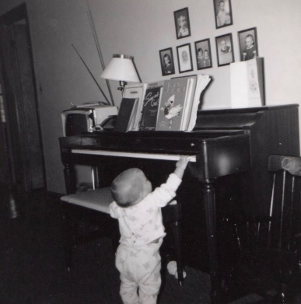

Alan in October. Continuing the tradition.

**10-12-61 -** Dear Mother and All, Glad to have your card today. I have meant to write, but just haven’t done it. Guess I thought you were busy and we’d see each other soon. Glad to hear M.J. and Jana Kay are getting along OK. We’ll plan to come for you this Sat as planned. Sat is much better than Sun since Ruth has her s.s. class and I have a little solo during the anthem this Sun. If you want to stay another week we could come the next Sat just as easily. We’ll plan on coming this Sat, however, unless you let us know. We’ll try to get there as soon as we can without driving too fast. Your time is still different from ours, I guess so 11:30 would be 12:30 here.

Our weather has been very warm the last few days, warmer than usual for this time of the year, I guess. Ruth has a s.s. meeting tomorrow night. I go to choir practice tonight. Last Sun we all went to church. The Sun before I stayed home with Alan as he had a touch of cold. I had some also but we’ve been OK since. Sat Alan had a Dr. appointment and got a vaccination. He’s felt pretty good since until tonight and seems irritable. We haven’t heard from the Laidigs for almost 2 weeks, but assume the’re OK. Last Fri Ruth had a Dr. appointment downtown, so we left Alan with Mrs. Slocum, and I took the girls to the lab. They colored and played while I went to a class. A lady technician watched them.

**10-28-61 – 4:30 Sat –** We were glad to have your letter and hear that you had a good trip home. We were glad you could visit and feel free to come anytime you want. You may send this on to M.J. and Bill if you want. I’m watching the Wisconsin-Ohio State football game on TV; its from Madison so I imagine M.J. and Bill are there. I’ve forgotten when you said Aunt Clara would be home.

Today has been cloudy and rainy but not cold. This morning I watched the magic programs ha! and cleaned in the living room while Ruth started in the basement. I may work down there tonight. Jim Johnston, the man to the South, brought their playpen over this afternoon. Ruth had talked to Mrs. Johnston at a party last Wed night and she said we could borrow it. Alan seems to like it and it should help him in walking. As you know he wants to be on his feet all the time and he often falls as he walks around the furniture. He’s crying right now and is refusing to walk around the edge. He crawls everywhere and the playpen will be handy to keep him contained occasionally.

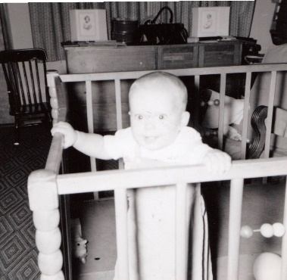

Alan contained.

Ruth has gone shopping now and will go by the drugstore to leave some of her library books. Tomorrow morning we’ll have to go early again as I again have a short solo part in the anthem “The Holy City.” We should be home in the afternoon and then in the evening we’ll be going over to Carol and Jack Duvalls. Mrs. L wrote that she’ll come up the middle of Nov. Mr. L won’t be able to come because of his Rotary. She said she wouldn’t come if Ruth and the children went to Kansas while I made that trip, but since I’m not going I’m sure she’ll come. She’ll stay a week.

Last Sun night Alan felt much better after he calmed down in the car and had a cookie. As you remember Alan was quite fussy in the station. We drove right back out Congress to Carol and Jack’s. Jack was asleep – he works some at night so we visited awhile with Carol and saw some of the improvements they’ve made. We were home Mon and Tues nights. There was a circle meeting at the church Tues but we missed – the men were invited also. Wed night I went to choir practice and Ruth went to that party at a neighbor’s. It was a toy demonstration by some company – something like those Tupperware parties that Deloris Harbough has. We were home Thurs and Fri night. Guess that’s all the news. Tell all hello.

**11-6-61 – Mon 11:30 AM –** Glad to have your letter this last week. I’m writing this at home since I’m recovering from the intestinal flu. We all had it. Lesle had it first last Wed night, with vomiting etc. Fri was Ruth’s appointment downtown but we had to call that off. I was going to take the girls down with me like I did the other time and Alan would go stay with Mrs. Slocum. We’ll go next Fri if everyone is feeling OK. Alan and Lisa woke up vomiting Fri night and it was 4:00 AM before they were quieted down. They felt some better Sat but Ruth came down then. Luckily I felt OK Sat so could help with the children. Yesterday I came down with it so Ruth had to miss her class. The adult choir was off as the children were singing so I didn’t miss that. I don’t think I’ve ever felt worse than I did yesterday, but I feel better today, although tired. Lisa got up tired this morning and tried to vomit but doesn’t seem too bad. I should feel OK for work tomorrow.

We were having Carol and Jack Duvall over tonight for supper. However, the’ve been called to Denver by the death of her Mother. She committed suicide I guess. They wouldn’t have wanted to come with our flu anyway.

That was too bad about Howard West. I guess I haven’t seen him since way back in high school, but he was certainly a good friend then. I can remember playing basketball on the church team with him. Wed night there is a coffee after choir practice so Ruth may go with me if we’re all feeling OK. The girls went trick or treating here in the neighborhood before it was dark. They had witch costumes made of crepe paper. They wouldn’t wear their masks.

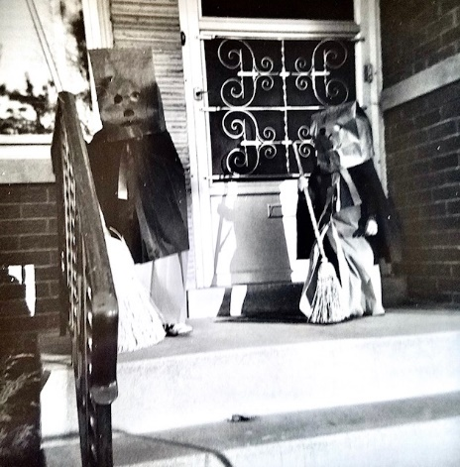

The masks we wouldn’t wear. Do you blame us?

Wed the girls were invited to an “after Halloween” party which was really a pre-birthday party for Steve (He was 4 next day – boy to North). The mothers were invited for coffee, too. Wed night I went to choir practice. We all went to s.s. and church last Sun. My solo part went OK. Hope you’re all OK and glad Aunt Clara got home OK.

**11-14-61 – Tues 6:45 PM –** I’ll write this now and try to get it over for the last pick-up at the post-office. Our weather has been on the cool side, but pretty much normal for this time of the year, I guess. Well, we’ve been here almost a year. My final exam was Nov 18th, we arrived here the 22nd and I started to work on the 25th. Still haven’t heard about my fellowship renewal but should by the 25th. The research is going fine. Glad to have your letter today and the one from M.J. yesterday. We were, of course, saddened about Bill’s Mother. All he said to me over the phone was that they had found her burned. Was it entirely accidental or did she take sick also.

We’re all recovered now and are feeling normal. I think we must have had the flu since we did not all take sick at the same time. I felt fine on Sat after Alan and Lisa had been sick in the night and Ruth was sick during the day. Alan is doing fine and ate a whole chicken leg for supper. He practically walks by himself. This morning we all got ready and went to get Mrs. L at the train. She had been unable to call us here or at work so assumed that we were on the way to pick her up. We brought her on out here and I went back down to work. I left work early and had the car worked on.

Tomorrow night is choir practice and Dallas Musgrave and Carol will be over Sat. I need him to help me carry the air conditioner to the basement. It lets a draft in the living room. Dallas is due for an army physical so might not get to go back to college. Mrs. L will stay until next Sun so we’ll have a visit about like you had. M.J. said they would plan to come for Thanksgiving and that’s not far off.

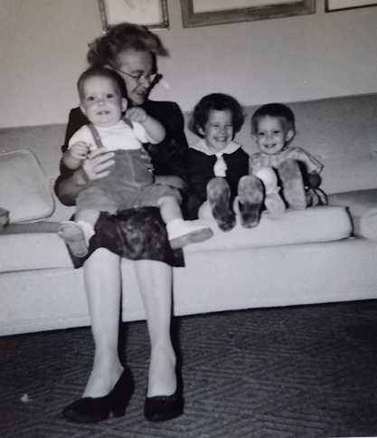

With Grammy. These are Alan’s special shoes – called “reverse last” shoes.

Last Sun we all made it to church OK. We had a good choir and Ruth had 10 in her class. Stayed home the rest of the day Sun. Sat morning we went to Elmhurst and got new shoes for Lisa – luckily Lesle won’t need new ones till next month. We stopped for that Top Value stamp store but they had moved. Got the girls some new books at the book store. We were home in the afternoon and then went to stamp store in Oak Park and by the drug store. In the evening we went to Carol and Jack’s. They bought some pizza.

Last Wed night we got a babysitter and both went to choir practice. Afterwards one of the members had a coffee at her house. Ruth and the children went to a guild tea Thurs afternoon. Too bad about Eli Farney – he was a fine musician. I think he had stomach difficulty at least one time. So many fellows who played under him have doctors degrees, one a DVM, Dick Searl, Phil Godwin, Nelson Bachus, Jim Stout, Rex Ehling. Show this to Aunt Clara and you can send to M.J. and Bill if you like – we’ll write them soon.

**11-26-61 – Sun PM –** We’re all home this Sun afternoon. Last Sun afternoon we came home after church, had a quick lunch, and I went back to help on the every-member canvas. Another fellow and I had 6 places to call on. I guess the drive was successful; our church is reasonably “wealthy” although not all, of course. After calling I just made it back in time to get Mrs. L down to the station (Union). Her train was at 5:00 PM and I got her there at 20 till but didn’t take time to get out as Lesle was with us. It was the fastest trip I ever made downtown but didn’t get a ticket ha! I never drive that fast normally. We had lots more time for your train that time.

We’re watching the State Street Christmas parade on TV. Such a crowd. I’m glad we didn’t try to go down. Today is cloudy but is warmer and didn’t need a topcoat this morning. Glad to have your letters and your call on Thanksgiving. I told M.J. before you called that we would call you all later if you didn’t call us first; when the phone rang I said that it was probably you folks. They left Madison about 10 and got here around 1:30. As you remember it took us about 3 hours also. They stopped once on the way down. It was too dark by the time we had dinner and rested awhile so we didn’t take a ride. They can come back in the spring and I’ll show them where I work etc. Bill helped me carry the air conditioner to the basement. (I got the storm windows for the screen doors up yesterday). We thought M.J. and Bill would stay all night but since the weather was so good they decided to go on back so Bill could get some studying in. They had a sandwich and left about 7:30.

I went to work Fri and yesterday morning we got some packages wrapped. Ruth finished that quilt for the Corman child in California. We’re mailing candy to our friends the Brownfields (lived across from us on the hill) who are now in Turkey, and to Ruth’s foster brother and his wife (Delbert) who are in Germany (he’s with the army). Yesterday afternoon Ruth cleaned the kitchen walls and windows and I got the record player to working. **Henceforth**, we listened to some of our records that we got last Christmas and had never heard. We were home the rest of the day doing more odd jobs, etc.

This morning we all went to church. We’re having a men’s quartet for the couples’ club Christmas Party in Dec. Alan just went down for his nap and I’ll take this over to the P.O. in a little bit. Thanksgiving morning Ruth and the girls went to the Thanksgiving service at the church. I stayed with Alan and did some cleaning. Alan had a runny nose but we think its his teeth as he cut 2 in the last 3 weeks. Alan and Lisa stayed home from church last Sun with Mrs. L. Lisa had a runny nose.

Last Sat (wk ago) night Dallas and Carol came over for supper while Mrs. L was here. He’s not sure yet he’ll go back to school at KU or not. Show this to Aunt Clara and Uncle Clyde etc. We might go to Madison at Christmas time if the weather is clear. If anyone there can come it’s fine.

**12-8-61 – Fri AM –** I’ve been waiting for the letter from M.J. but it hasn’t come yet so I’ll go ahead. It’ll probably come today. Today is our coldest day of the season, but it is clear this morning. It is supposed to rain or snow tomorrow. Had your short letter yesterday. Yesterday evening I picked up the 29” springhorse for the girls’ Christmas. They need something like that to wear off some of the energy. We have a lot of Christmas finished but still have to get a tree and a few presents. Ruth has made a lot of cards and has them ready to go. We ordered some picture (of kids) cards for close friends and relatives but they haven’t arrived yet. We’ll be at home tonight and in the morning will get shoes for Lesle.

In the evening (Sat) the couples’ club is having their Christmas party. I’m singing 2 carols in a quartet. Santa Claus narrates where he been the year before and the narration is interrupted by the various acts illustrating the various places. Sun morning I have a short solo in an anthem we’re also singing at the pageant on Dec 17th (5:00 and 7:30 performances – music and tableau). There will be Christmas Eve and Christmas morning services also, so you see we have a busy time.

My fellowship situation is still the same. The committee which acts on applications in my area is meeting about now but it’ll be awhile before I hear. My application for a temporary appointment to be paid off of Dr. Abood’s grant is in and there’s no reason it won’t be approved. It would cover from Dec 1st till I get the fellowship renewal. They had to do this for one of the last Public Health Fellows who was there also. I just applied for 1 year, rather than 2, in the beginning, so my renewal has to compete with new applications. I had an inquiry from Strasenburgh Labs in Rochester NY about an opening they have for a neuro-pharmacologist. It is a small pharmaceutical house and Dr. Peters gave them my name.

Last Wed night I had long rehersals for choir and quartet and Ruth went to AAUW (The American Association of University Women, a non-profit organization that advances equity for women and girls through advocacy, education, and research.) with a friend at the church. It is a small group in this area and all are young. I told her she could join for one of her Christmas presents.

I got our record player fixed so we’ve been enjoying our records again. Ruth and the girls like to play the Christmas carols. Last Sun we all went to church. In the afternoon I had a rehersal at the church. Last Sat Alan went to the Dr. – 22 lbs 2 oz and 29½ in. He still has a runny nose but I guess its largely teeth. The girls cough a little but we haven’t got down yet. Mon evening Ruth helped a neighbor with her sewing. She is about the only one around who does any sewing. A week ago Tues Ruth went to guild at church. Our other schedule has been the same. Hope you, Aunt Clara, Uncle Clyde and all are OK. I am looking forward to your letter.

**12-17-61 – Sun 3:15 PM -** We’re all resting now so I’ll take time to write this. The children were glad to have your Santa letters and we were glad to have your card. Our vacation plans are somewhat indefinite at this time. I will probably go to the Federation Meetings in Atlantic City in April, and there is a possibility we might extend that and go to Kansas, also. Since our vacation was so early last year I wouldn’t hesitate in taking more time off than just for the meetings. That might be best, since if I take a job somewhere other than in the Chicago area we might be moving during the summer. They have a placement service at the Federation Meetings which I may utilize.

Today we have two performances of a Christmas pageant at the church. One at 5:00 and one at 7:30 PM. We’ll have the babysitter from across the street stay with the kids and give them their supper as Ruth is going to help out in the choir. We’ll take sandwiches and eat between programs. The adult choir supplies most of the music and I have a short solo part in the opening anthem as we all stand at the sanctuary front before processing back to the choir loft (I’ll send you the program).

Tomorrow night the Duvall’s (from Pittsburgh) will all be over for supper. Wed night I may miss choir practice so Ruth can take Lesle to a childrens Christmas party at the church. Next Fri night we may go meet Dr. Al Poisner at the airport, and then bring him here to stay overnight. He’s the fellow from Kans. City who went to KU Medical School and worked with Dr. Walaszek some and then interned here at the U of Ill last year. He is on a post-doctoral fellowship at the Albert Einstein School of Medicine in New York City and plans to be a pharmacologist. Sat I’ll take him to the train or to visit some of his friends.

Next Sun night will be a Christmas eve service and on Christmas afternoon we may go over to the Duvalls awhile. M.J. wrote inviting us up for Christmas day but we won’t try to go then. We might take off another day that week and go up, however. Yes, the girls have a crèche (I guess Ruth told you).

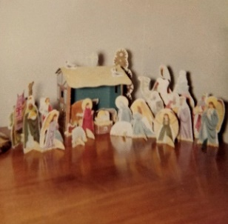

We got our tree Thurs night and decorated it yesterday. It is pretty – it’s over in the corner by the front windows; we moved the big rocker to Alan’s room. Ruth bought a centelabra with 3 thin tapers and has it on the chest by the front window. Alan touched a hot bulb once so has stayed away from the tree pretty well. Ruth has made many of the cards we sent to non-relatives and still has some more to do. We sent the picture ones to relatives mainly. Ruth and the girls made a box of Christmas decorations and gave them to Carol and Dallas for their first Christmas as husband and wife. We still have some presents to mail although most of them are now bought.

Yesterday morning we stayed at home. I took some shoes to be fixed and my briefcase to be mended. I’ve carried it every day to work since the time you gave it to me and it is just now breaking at the seams. Since I often have heavy books I guess it has held up quite well. We had a card from Leila today.

Yesterday afternoon I watched the Kansas football team beat Rice in the Blue Bonnet Bowl game at Houston, Texas. Afterwards we had a babysitter and went to rehersal for the pageant. We bought pizza pie on the way home; the girls love it and so does Alan. We had Carol and Bruce Ferguson over for dessert in the evening. He’s my age, is s.s. superintendent at our church, they live in Fr. Pk, and he teaches in Elmwood Park. We met them the first Sun we went to church and have always been friendly but had never had them over. Their 6 year old girl is in Ruth’s s.s. class.

Fri morning I stayed home and Ruth finished sewing a new dress. In the afternoon she did some shopping downtown and had her Dr.’s appointment. He been watching a slight condition which seemed to be better this month. Alan stayed across the street with Mrs. Slocum and the girls went to the lab with me. They always have a big time there and the women “spoil” them. Ruth took a cab out from downtown like you did. Last Wed night we had Pam and Ruth and I went to choir rehersal. Here’s hoping you all have a nice Christmas and we’re sorry we can’t get down. You’re all welcome here at any time as you know. Show this to Aunt Clara, Uncle Clyde etc.

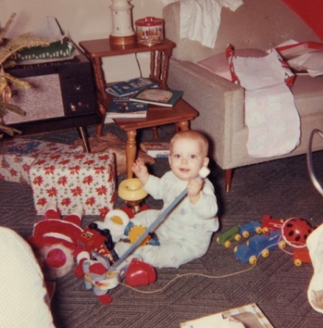 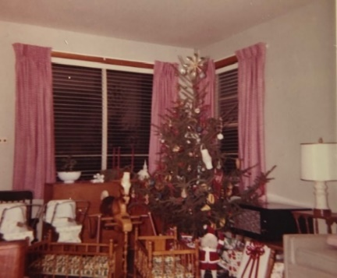 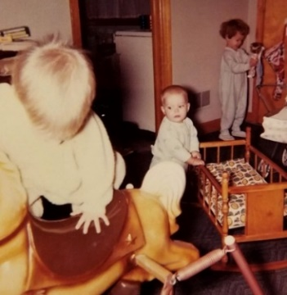

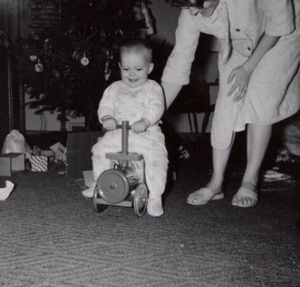 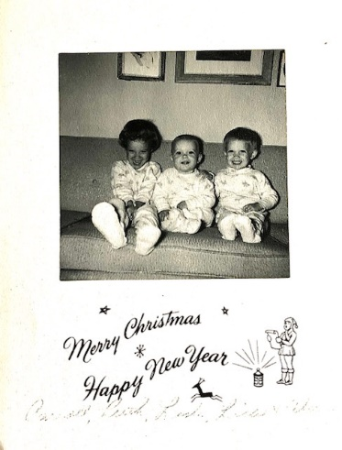 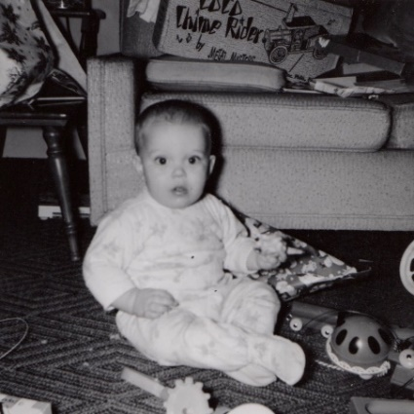

Merry Christmas from 1961!

**12-29-61 – Fri 3:30 PM -** Thanks again to all for the Christmas gifts which helped make our day most enjoyable. We trust yours was the same. The last few days have been very cold, zero and below, but have been more clear than usual. The car has started OK so far even though it takes a while. A year ago, just before Ruth went to the hospital, I had trouble starting the car and had her worried. I shoveled all the snow out of the street where the car stands, otherwise the car would easily get stuck since I don’t use chains. The only place I could use chains would be the few blocks near here before you get to the main streets, which are soon clear after a snow.

Alan just got up from his nap and is teasing me, something he often does now. He’s one year old tomorrow and is now taking several steps alone – more sideways than forward. Ruth and Lesle walked over to the store this morning and bought some gifts (toys) for Alan. Tomorrow night Dr. Tanaka and his wife are coming out for supper. He is a Japanese biochemist who is working for Dr. Abood and will stay in this country another year. We’ll call dinner with them Alan’s birthday dinner. We’ll leave the Christmas tree up till after they’re (looks like the ‘y’ was added in later) here. The trees seem to dry out earlier and shed more here than in Kansas. We’ve only had ours 2 wks and its quite dry.

Had a letter of clippings from M.J. yesterday and we sent your letter on to them. It was lucky we didn’t try to go to Madison as Lisa had quite a fever on Wed with a cold. Her fever was better yesterday and seems gone today but she’s still tired. She’s had quite a cough and could hardly talk yesterday. She’s had antibiotics etc. Lesls has had a cough and cold but wasn’t nearly as sick. Lesle has always been more resistant to colds than Lisa. As I told you on the phone Alan had a fever Sun and has also had a cough. We’ve been up quite a bit at night with coughing, crying children but they’re (another added in ‘y’ ☺) all much better today.

We had a note from Ken Holladay today saying he is in general practice at Eudora, Kansas – a little town between Lawrence and Kans. City. His home is at Lawrence, as you may remember and his wife is the one from Switzerland. (I lived in the trailer with him.) They have 2 children and are expecting a third. We now have friends and relatives to visit in Kans. City, Eudora, Lawrence, Topeka, Salina, Hutchinson and Oberlin. The Federation Meetings (we sent in the abstract for my paper this week) are the 2nd week in April so as I said we might go to Kansas around that time.

I didn’t go down to the lab today as I wasn’t planning to run an experiment and they were having a party this afternoon that I didn’t care much about attending. I still haven’t heard on my fellowship renewal and will not know till the 1st whether I’ll get paid for this month. Strasenburgh Laboratories in Rochester, NY answered my application and asked me to come back for an interview the last part of Jan. Irwin Neisler & Co is the drug house in Decatur, Ill. I’ll visit them when Dr. Abood has to go down Jan 17th. Both companies are “small” but the opportunities might be as good as with a larger one. Decatur is about 75,000 and is near Springfield in East central Ill.

There was no choir practice this week, so we’ve been home since Christmas. I’ve done the shopping as Ruth doesn’t like to drive on the ice and snow too well. Mr. L called Tues night and said he had been unable to get us Christmas night. Last Sun morning we had Mrs. Slocum take care of Alan as he felt feverish. I would have stayed with him but I didn’t want Ruth to drive alone with the girls. Sun night I took the girls to the candlelight service and Ruth stayed with Alan. Fri night as it started to snow we drove to Midway Airport to meet Al Poisner but his plane was delayed and he didn’t arrive till early morning at O’Hare. Most of the snow had fallen by then so I didn’t try to drive him downtown. He stayed here all day and we had a good talk. I shoveled the snow and drove him over to the train station. He took the train downtown and was to take a train to Kansas City. The girls got the big horse to ride and doll cradles and buggies besides smaller things. Again, I hope you’re all OK and give this to Aunt Clara and Uncle Clyde to read. Love, Ruth, Lesle, Lisa, Alan and Carroll

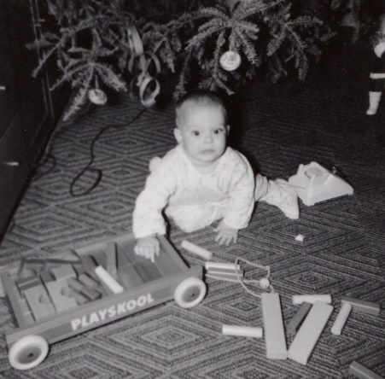 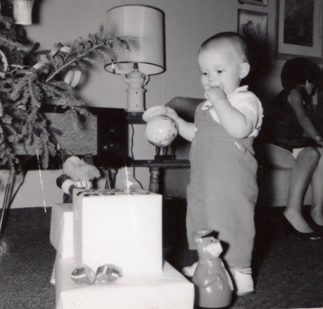 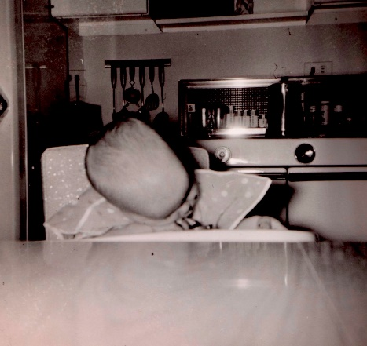

Alan’s 1st birthday – December 30, 1961